Ethereum Eyes $3,000 While MemeToro Adds 1,373 Solidity Lines to Its Open-Source BNB Chain Repository Release
Meta description: Ethereum’s $3,000 setup meets MemeToro’s 1,373-line open-source release for a planned BNB Chain fair-launch ecosystem.

Ethereum is trading close to $2,770 after moving above $2,600 for four straight positive sessions. The market is now watching $2,700, a Fibonacci resistance level that could become support if ETH closes above it on a weekly basis. A successful break may place the $2,950 to $3,000 range in view.
This Ethereum rally is also renewing interest in smaller blockchain projects with product milestones.
MemeToro is one example. Its Stage 7 presale has passed $140K at a token price of $0.00430, while the project has published 1,373 lines of Solidity across 17 files. The code release gives buyers a technical development point to assess.
Ethereum has a mature network and deep liquidity. MemeToro is a high-risk early project that still needs to turn public code into a working AI-guided BNB Chain launchpad.

Understanding MemeToro’s Open-Source Development Release
MemeToro’s public repository includes a FairLaunchEscrow contract, interfaces, tests, and supporting documentation. The release is licensed under MIT, which means developers and researchers can review the code and understand the stated contract design.
The 1,373 lines of Solidity are meant to outline a launch system with fixed rules. The project says its fair-launch design will lock launch settings at creation and avoid an owner or admin path that could quietly change allocations later.
The stated code goals include:
- setting contributor and liquidity allocations to 100%
- rejecting insider allocations in the fair-launch split
- allowing funds to move only to refunds or planned liquidity
- giving users public claim, refund, and finalization options
This is important because presale buyers often have little information beyond a token price and roadmap. The MemeToro presale gives users a chance to inspect the project’s intended technical model. Public code is not a guarantee of security or adoption, but it offers a more concrete starting point for research.

Ethereum’s $2,672 Test Could Open a Path Toward $3,000
Ethereum’s move above $2,600 is being supported by stronger institutional interest. Spot Ethereum ETFs reportedly recorded $143.8 million in single-day inflows, led by BlackRock’s ETHA. This can support confidence because it shows demand from larger market participants.
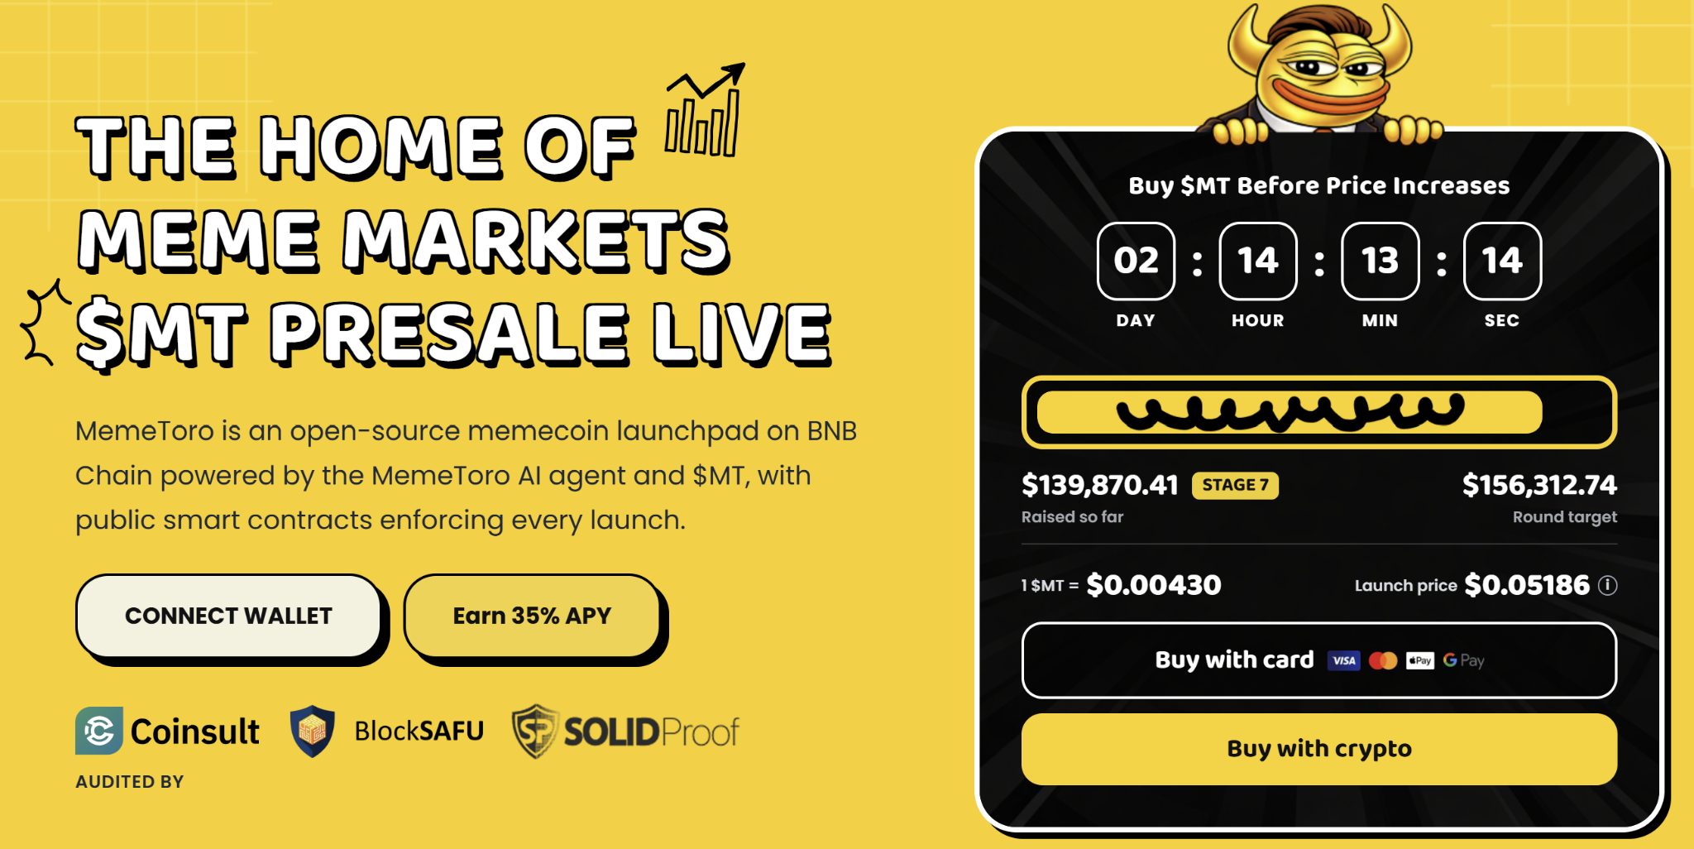
The immediate question is whether ETH can hold above $2,672. If a weekly candle closes above this Fibonacci level, market analysis points toward $2,950 to $3,000. If Ethereum loses momentum, it could remain in a horizontal range while holding above the 20-day EMA near $2,434.
Ethereum’s outlook is built around a live, widely used network. It also has the planned Glamsterdam hard fork in Q4 as a future catalyst. That makes ETH very different from the MemeToro presale.
For investors, Ethereum can offer an established altcoin position. MemeToro offers a smaller early-stage opportunity built around AI launch tools and transparent launch rules. The possible reward may be larger, but the delivery risk is also much higher.

Why Public Code Matters for a Future Memecoin Platform
MemeToro is not only planning a token sale. It is aiming to build an ecosystem for memecoin creation, discovery, and trading on BNB Chain. Its AI agent is intended to help creators choose token distribution and funding mechanics. The public smart contract framework is then meant to enforce those choices.
This may help make memecoin launches easier to understand. A buyer could check whether the allocation rules are fixed and whether launch funds are limited to refunds or liquidity. That does not stop all market risk, but it may reduce the need to trust a creator’s private promises.
The project still has major tasks ahead:
- deploy the contracts for real users
- complete testnet and liquidity work
- connect the AI agent to the launch process
- receive an independent security review
The open-source release is a positive development milestone, but it is not the finished product. The long-term $MT case depends on whether these tools can bring creators and traders to the planned memecoin platform.

A Simple Path to Buying $MT Tokens
Every purchase runs through an automated contract. No manual approval, no waiting around:
- Access the Sale: Visit the official presale portal linked from the MemeToro homepage.
- Prepare Your Wallet: Connect a non-custodial wallet set to BNB Chain.
- Choose Your Currency: Pay with BNB, ETH, USDT, USDC, or a card, whatever fits.
- Verify the Purchase: Complete the transaction and your tokens are secured on-chain.
Holding $MT is more than owning an early-stage asset. It gives you a stake in staking rewards, trading features, and everything else MemeToro rolls out as the platform grows.
Buyers should only use the official how to buy $MT page and should never share their wallet seed phrase.

FAQs

Why does Solidity matter?
Solidity is a programming language used to write many blockchain smart contracts. Public Solidity code lets people inspect the stated rules of a planned system.

Can Ethereum reach $3,000?
It may if ETH can turn $2,672 into a support level. The target remains a technical forecast, not a certainty.

Is MemeToro’s launchpad ready to use?
No. The project has released code, but deployment, testing, liquidity execution, and independent review are still needed.
More Information on MemeToro ($MT) Presale Here:
Website: https://memetoro.com/
X: https://x.com/memetoro_mt
Telegram: https://t.me/memetoro_mt
YouTube: https://www.youtube.com/watch?v=gY0jgWy_DtA

