XRP Holds Near $1.50 as MemeToro’s $140K Stage 7 Presale Builds AI Utility for Memecoin Creators and Traders
Meta description: XRP holds its $1.50 range as MemeToro’s $140K Stage 7 presale develops AI utility for BNB Chain memecoin creators and traders.
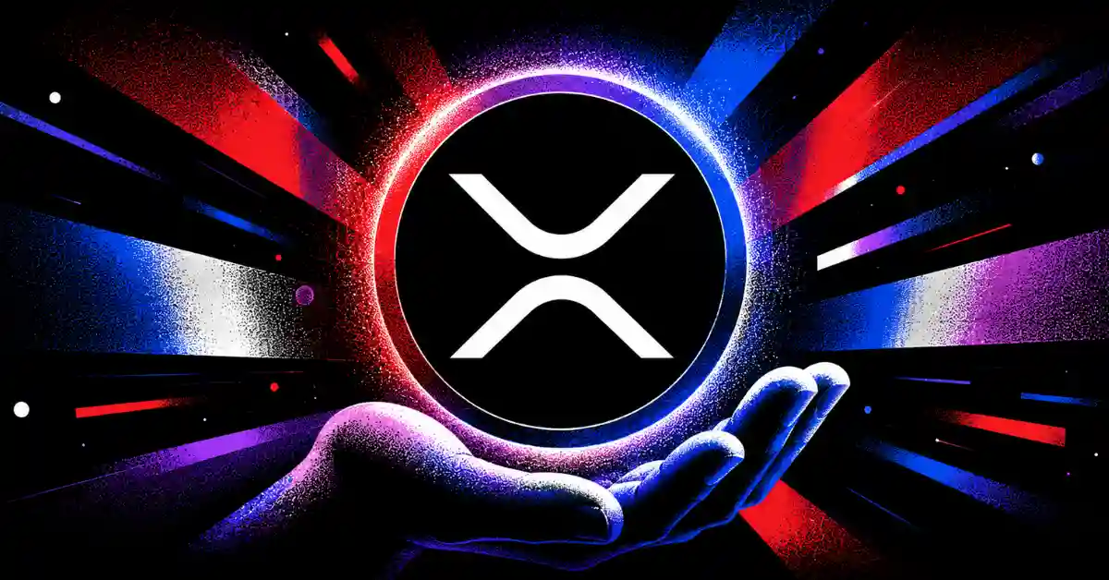
XRP is trading in a stable $1.50 to $1.60 range as buyers defend an important support area. The token has held above its wider moving averages, while a bull flag pattern has kept traders focused on a possible next move. A sustained break above $1.50 could support a chart-based target near $2.10, although that result is not guaranteed.
This stable XRP backdrop is leading some crypto users to research smaller projects with a different growth profile. MemeToro is building a planned AI-powered platform for memecoin creators and traders on BNB Chain.
XRP is an established asset with active order books. MemeToro is a much earlier and riskier project whose value depends on whether its AI tools, public code, and future trading features can attract users.

Exploring MemeToro’s AI Utility for Creators and Traders
MemeToro is developing a BNB Chain ecosystem for memecoin creation, discovery, and trading. Its AI agent is designed to help creators set token distribution and funding mechanics before a launch begins. The intended goal is to make the setup process easier while adding rules that are clear to potential buyers.
$MT is planned to support premium access, transactions, launch funding, staking, rewards, and other platform activity. The roadmap also includes prediction markets, a news portal, and future memecoin trading tools.
The proposed AI utility has two sides:
- creators receive help setting launch terms
- traders can review clearer launch settings
- contracts are designed to apply the final rules
- $MT supports activity across the planned ecosystem
These features are still in development. The MemeToro presale gives buyers early access to the project, but its long-term case depends on real product delivery. A useful AI agent could help creators, yet only active users and secure contracts can turn that feature into lasting $MT demand.
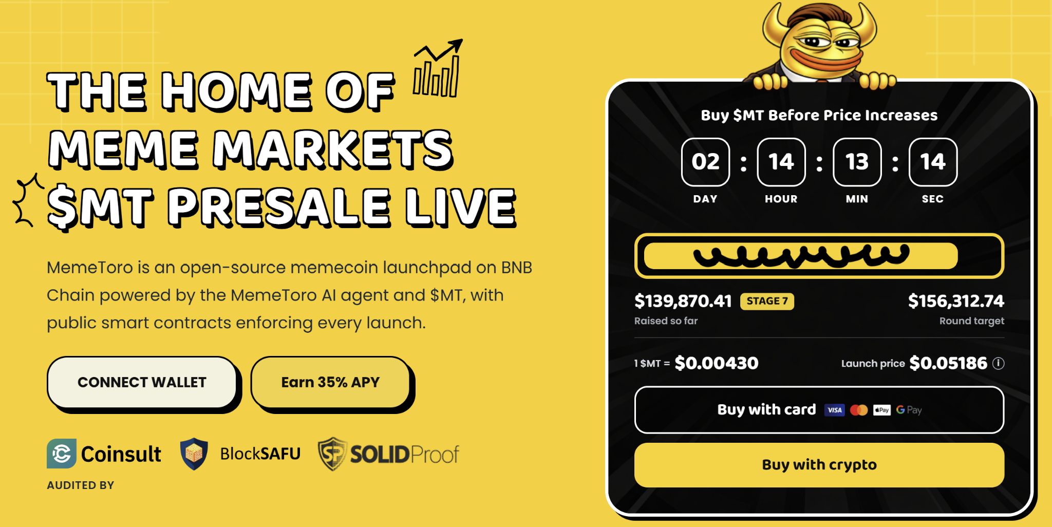

XRP’s $1.50 Level Remains the Main Technical Test
XRP’s current range between $1.50 and $1.60 shows that buyers are still defending the asset in high-liquidity markets. Prediction-market data reportedly places more than 92% consensus on XRP holding its $1.42 structural floor through the current weekly close.
The token is also showing a multi-week bull flag pattern. This setup is often watched by technical traders because it can signal a pause before another upward move. XRP has bounced from its support area and remains above key moving averages, while momentum indicators suggest continued retail accumulation.
The next step is a clear move and hold above $1.50. If this happens, chart analysis places a near-term Fibonacci target around $2.10. Longer-range $8 forecasts are far more speculative and depend on many factors, including enterprise payment use and legal conditions.
XRP offers a live-market trading story. MemeToro offers a planned utility story. Buyers should not treat a Stage 7 presale as equal in risk to a large token with established liquidity and a long market history.

Why MemeToro’s Stage 7 Progress Matters
The MemeToro presale has raised more than $140K in Stage 7 at a price of $0.00430. This early funding is important because it supports the project’s goal of building an AI-guided fair-launch system. The project displays a $0.05186 launch target, but this is not a promise of future price.
MemeToro has also published 1,373 lines of Solidity across 17 files under an MIT license. The code outlines a FairLaunchEscrow design intended to lock launch rules, prevent insider allocations in the stated fair-launch split, and route funds toward refunds or planned liquidity.
This open-code approach gives creators and traders a point to research. It may also create a stronger utility story than a basic meme token. Still, the contract system needs deployment, testing, liquidity execution, and independent security review.
For buyers, the attraction is clear. $MT is priced much lower than established assets such as XRP, and it is connected to a future platform. The risk is also clear. If the AI launchpad fails to gain users, the token may not develop the utility its roadmap describes.
Buyers should use the official how to buy $MT guide and only risk funds they can afford to lose.

FAQs

What price level is XRP traders watching?
The $1.50 level is the immediate ceiling. A sustained move above it could support a chart-based target near $2.10.

What is the current MemeToro presale price?
$MT is priced at $0.00430 in Stage 7, with more than $140K raised under the latest update.

Is MemeToro’s AI platform live?
The AI agent and wider platform are planned. The project has released public development code, but the full product is still being built.
More Information on MemeToro ($MT) Presale Here:
Website: https://memetoro.com/
X: https://x.com/memetoro_mt
Telegram: https://t.me/memetoro_mt
YouTube: https://www.youtube.com/watch?v=gY0jgWy_DtA

