HYPE Price Prediction: Hyperliquid Hits $94 as MemeToro Stage 7 Passes $140K With AI Launchpad Plans
Meta description: HYPE reaches $94 on borrowing and retail-perpetual demand as MemeToro’s $140K Stage 7 presale advances its AI launchpad plans.

Hyperliquid’s HYPE token has reached a new all-time high near $94 to $95, making it one of the year’s strongest large-cap performers. The token is reportedly up 272% year to date, helped by a new native lending feature that lets users borrow stablecoins using HYPE as collateral. Plans to expand retail perpetual futures access in the United States have also increased interest.
The HYPE price prediction now depends on whether new utility and trading demand can support the latest highs.
MemeToro has a different growth story. Its Stage 7 presale has passed $140K at $0.00430, and the project is building an AI-guided BNB Chain memecoin launchpad.
HYPE is tied to live lending and perpetual-market demand. MemeToro is a much earlier project whose potential depends on public fair-launch code becoming a real platform for creators and traders.

What MemeToro Is Building With Its AI Launchpad
MemeToro is developing a planned BNB Chain platform for memecoin creation, discovery, and trading. Its AI agent is meant to help creators decide token allocations, funding structure, and launch settings. The goal is to make launch planning simpler without hiding the important rules from buyers.
The project has released 1,373 lines of Solidity code across 17 files. The public code includes a FairLaunchEscrow contract, tests, interfaces, and documentation. It is designed to lock settings at creation and reduce developer-insider control.
The stated fair-launch protections include:
- no insider allocation in the fair-launch split
- contributor and liquidity allocations that total 100%
- funds routed only toward refunds or planned liquidity
- public claim and finalization processes
This is a strong transparency idea, but it is not a finished product. The contracts still need deployment, testing, liquidity execution, and independent security review. The MemeToro presale gives buyers an early entry point, while the planned AI launchpad must still prove it can attract activity.

HYPE’s New High Is Linked to Live Product Demand
HYPE’s rise toward $95 is not only a chart move. It has been supported by a native stablecoin borrowing feature. Users can lock HYPE as collateral and borrow stablecoins on the network. This gives the token a direct utility role inside the Hyperliquid ecosystem.
The project is also working on regulatory filings to bring perpetual futures products to U.S. retail customers.
If successful, this could expand the user base and liquidity pools for the platform. It also shows why HYPE has become a product-led large-cap story rather than only a momentum trade.
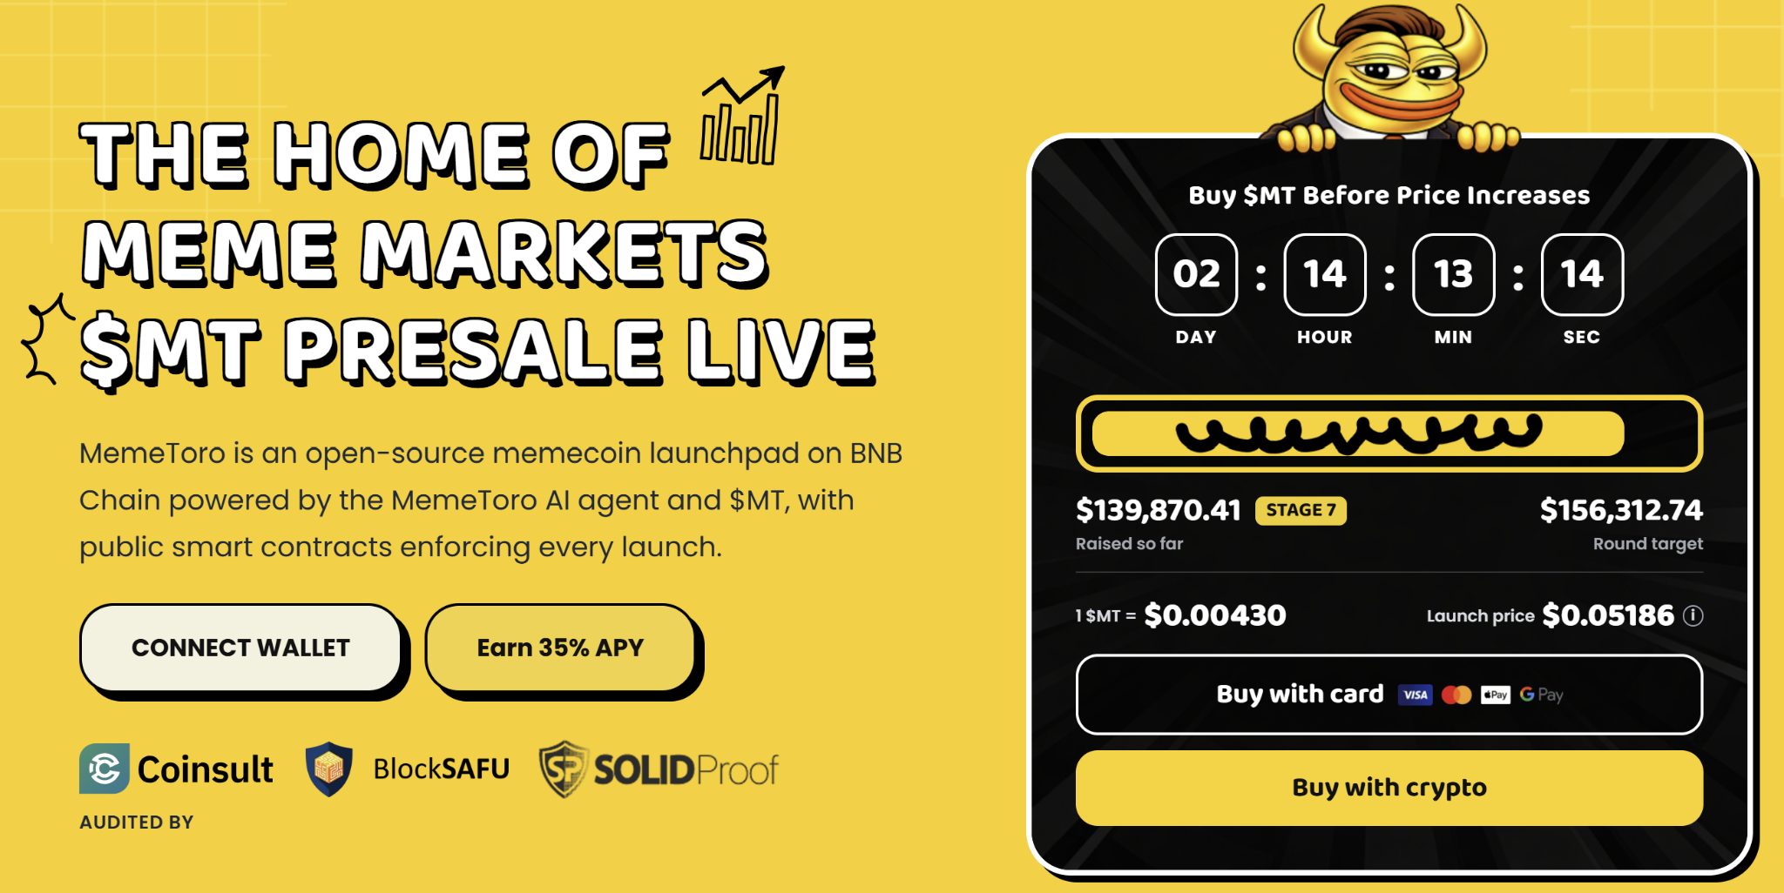
The HYPE price prediction remains uncertain despite the strong trend. New all-time highs can attract buyers, but they can also bring profit-taking. The token has already gained sharply this year, so market conditions and user growth will matter.
MemeToro does not have these live features yet. Its opportunity is earlier and more speculative. The project must convert its open-code fair-launch design and AI agent plan into real services before it can match the type of utility-driven demand that Hyperliquid has already built.

Why $MT Utility Could Create a Different Growth Path
$MT is planned to connect activity across the MemeToro platform. It is intended for premium access, transactions, launch funding, staking, rewards, and future memecoin trading. The roadmap also includes prediction markets and a news portal.
The AI agent could help creators prepare launches. The fair-launch code is then designed to enforce the agreed rules. If creators and traders use the platform, $MT may gain utility from repeated activity rather than only one presale event.
This is the key difference between HYPE and $MT. HYPE already has live borrowing utility and a large trading ecosystem. $MT has planned utility tied to a future BNB Chain launchpad.
The bullish case for MemeToro is that it enters a fast-moving memecoin market with fairer rules and easier AI-guided setup. The risk is that the roadmap may not be completed on time or may not attract enough users. Early buyers should understand that difference before comparing $MT to an established live token.

MemeToro Token Economics: What’s in It for Users
The token distribution for the 1.2 billion total supply of $MT tokens is structured to align long-term platform utility with user participation. The verified smart contract is hosted at 0x44....a8cfff.
Core Distribution Architecture:
- Public Sale Allocation: 71% of the total supply goes to public buyers.
- Exchange and Operations: 10% is held for exchange liquidity and 5% for platform trading.
- Growth and Rewards: 7.56% goes to marketing partners and 4.44% to user rewards.
- Team Retainment: 2% is reserved for the core development team.
To support structural stability, marketing and partner tokens undergo a 24-month vesting schedule. Presale purchases are completely exempt from vesting and are entirely distributable on the launch date. Verified holders can participate in the network's staking mechanism, which currently offers up to 35% APR in programmatic rewards.

FAQs

Why did HYPE reach a new high?
The move has been linked to its native stablecoin borrowing feature and potential expansion of perpetual futures products to U.S. retail customers.

Is MemeToro’s AI launchpad active today?
No. The project has published fair-launch code, but its full AI launchpad and trading tools are still in development.

What is the $MT Stage 7 price?
$MT is priced at $0.00430 in Stage 7, with more than $140K raised in the presale.

