Best Memecoin to Buy: Why MemeToro’s $0.00430 Stage 7 Price Draws New BNB Chain Buyers Today
Meta description: MemeToro’s $0.00430 Stage 7 price and $140K presale milestone draw BNB Chain buyers seeking AI launchpad utility and early access.

The best memecoin to buy is not always the token making the loudest social-media noise. Many buyers now look for a clear entry price, public product development, and a reason for the token to be used after launch. That is why the MemeToro presale is gaining attention at $0.00430 in Stage 7.
MemeToro has passed $140K in presale funding and is building a planned AI-powered BNB Chain memecoin platform. Its team has also made 1,373 lines of fair-launch Solidity code public. The combination of an early price, open development, and planned utility gives buyers more to study than a basic meme narrative.
Still, the best memecoin to buy remains a high-risk category. $MT must deliver its AI launch tools, fair-launch model, and future trading activity before its long-term value case can be proven.

Why the $0.00430 Stage 7 Price Is Drawing Attention
$MT is currently priced at $0.00430 in Stage 7. For early buyers, this matters because the project displays a $0.05186 launch target. The difference creates a possible upside case, but it does not guarantee that $MT will reach or hold that price after trading begins.
The MemeToro presale has raised more than $140K. This shows early interest, but the funding total should not be the only buying reason. The more important question is whether the platform can create a useful role for the token.
MemeToro is planning to use $MT for:
- premium tool access
- platform transactions
- launch funding
- staking and network rewards
- future memecoin trading activity
This is why the best memecoin to buy discussion around MemeToro is not only about its current price. It is also about the project’s attempt to build a broader BNB Chain ecosystem. The upside could be meaningful if the product attracts users. The risk remains high because the core platform is still being developed.
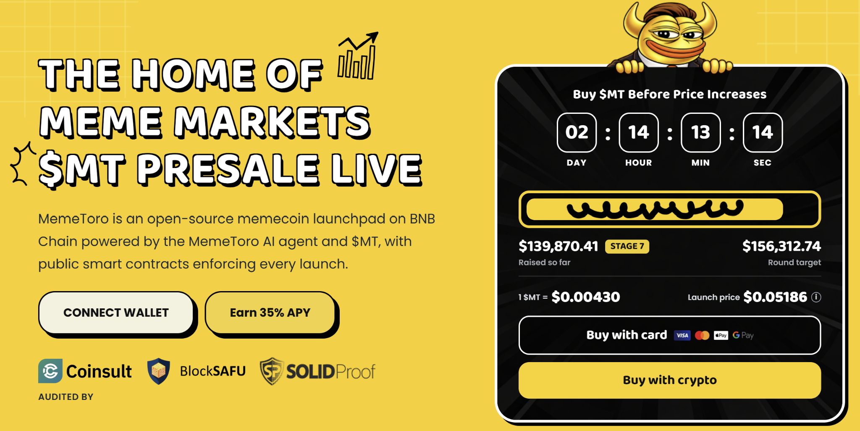

Understanding MemeToro’s AI and Fair-Launch Model
MemeToro is designed as a platform for memecoin creation, discovery, and planned trading. Its AI agent is intended to help users choose token allocations, funding mechanics, and launch settings. The goal is to make token creation easier for people without deep technical knowledge.
The AI agent is meant to work alongside a fair-launch smart contract system. The project has released 1,373 lines of Solidity code across 17 files. This code includes a FairLaunchEscrow contract, tests, interfaces, and documentation.
The stated fair-launch design aims to:
- lock important settings at launch creation
- stop insider allocations in the fair-launch split
- limit funds to refund or planned liquidity paths
- give users public claim and finalization functions
These are planned protections, not a guarantee of price success. The contracts still need deployment, testing, liquidity execution, and independent security review. However, public code gives the best memecoin to buy case a stronger research point than a project that offers only a roadmap.

How to Buy $MT During the Stage 7 Presale
Buying $MT is designed to be simple, but users should carefully confirm each step. The safest route is to begin at the official how to buy $MT page. This helps reduce the risk of using an incorrect payment link or fake website.
The basic process is:
- Open the official MemeToro presale page.
- Connect a compatible wallet and set it to BNB Chain.
- Choose BNB, ETH, USDT, USDC, or a card where available.
- Confirm the transaction and keep wallet details private.
At the current Stage 7 rate, a $600 purchase would buy around 139,535 $MT before card, processing, or network fees. If the displayed $0.05186 launch target is reached, those tokens would have a paper value near $7,236.
This is an illustrative scenario, not a promised return. Actual results can be affected by liquidity, slippage, taxes, fees, supply changes, and platform adoption. Never share a seed phrase or private key when purchasing any crypto asset.

What BNB Chain Buyers Should Watch Next
MemeToro’s early price is one reason buyers are watching, but product progress is the bigger long-term signal. The project’s public code is a strong first step. The next milestones will show whether the fair-launch concept can become a real BNB Chain service.
Buyers should watch for:
- contract deployment and testnet activity
- AI agent integration with launch workflows
- independent security review
- liquidity and trading implementation
- real creator launches using the system
The best memecoin to buy is not decided by a presale price alone. MemeToro’s $0.00430 Stage 7 price offers early access, but the future value of $MT depends on the team turning its code and AI roadmap into active platform utility.
More Information on MemeToro ($MT) Presale Here:
Website: https://memetoro.com/
X: https://x.com/memetoro_mt
Telegram: https://t.me/memetoro_mt
YouTube: https://www.youtube.com/watch?v=gY0jgWy_DtA

