Zcash Surges 200% as MemeToro Builds AI Tools to Limit Insider Manipulation During BNB Chain Launches
Meta description: Zcash’s 200% three-month surge highlights crypto demand as MemeToro develops AI tools and public rules to limit launch insider manipulation.
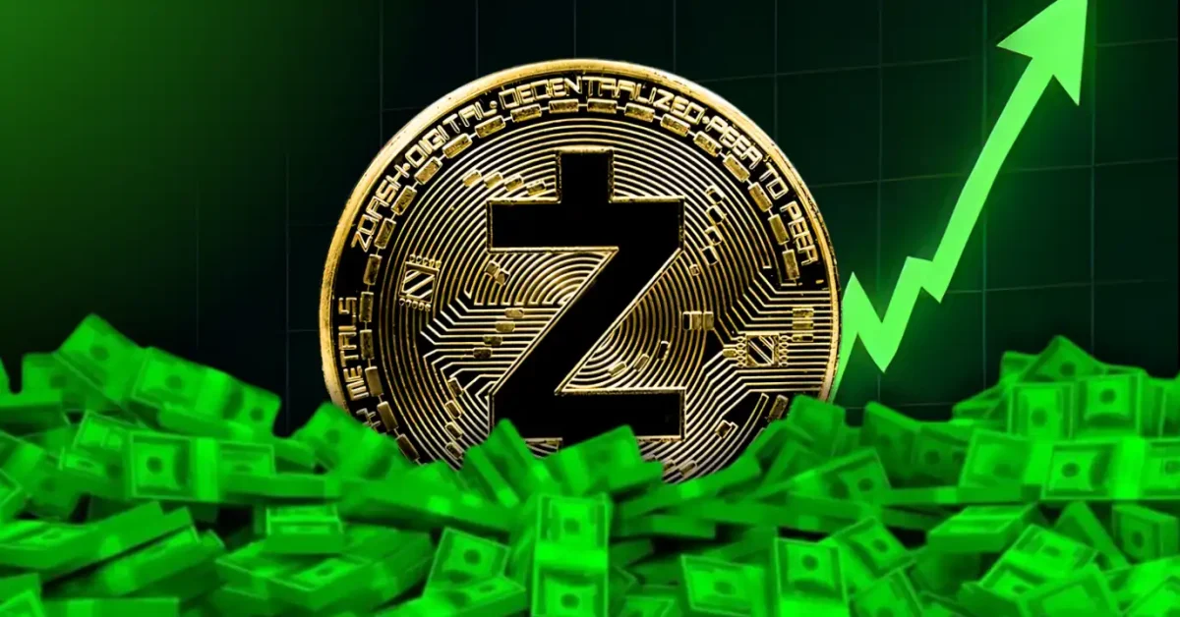
Zcash has surged about 200% over three months and remains above $1,500 after another 40% weekly rise. The privacy coin’s recovery has been driven by institutional interest, the planned NU7 upgrade, and growing attention around private transactions. ZEC is now testing resistance near $1,653, where a breakout could bring the $2,000 to $2,500 range into view.
At the same time, some early-stage projects are trying to solve a different crypto problem: insider manipulation during new token launches. MemeToro is building AI tools and public fair-launch contracts for BNB Chain creators.
The MemeToro presale has passed $140K in Stage 7 at $0.00430. Its goal is to help define launch settings in advance and limit the ability of developers to add hidden advantages. This is a high-risk presale story, but its code-first approach provides a clear topic for buyers to research.

What MemeToro Is Building for Fairer Token Launches
MemeToro is a planned BNB Chain ecosystem for memecoin creation, discovery, and trading. The AI agent is intended to help creators choose token allocations, funding mechanics, and launch details. The system then aims to use smart contracts to apply those rules.
The project’s open-source repository now contains 1,373 Solidity lines across 17 files. The development release includes a FairLaunchEscrow contract, interfaces, tests, and documentation. It is designed to give users more visibility into the intended launch process.
The stated anti-insider controls include:
- settings locked when the launch is created
- no insider allocation in the fair-launch split
- contributor and liquidity allocations totaling 100%
- funds restricted to refunds or planned liquidity
This does not eliminate every risk in a memecoin launch. Price volatility, low liquidity, and poor demand can still hurt buyers. However, fixed public rules could make it harder for a developer to change the basic allocation deal after participants have funded a project.

Zcash’s Rally Has Strong Drivers and Real Pullback Risk
Zcash has become one of the year’s biggest large-cap turnarounds. The token is above $1,500 after its 200% three-month gain and recent 40% weekly increase. Grayscale’s Zcash ETF reportedly drew $98.21 million in one week and now holds $914.53 million in assets under management.
The planned 3-for-1 stock split on September 30 may make the fund more accessible to smaller investors. Zcash also has a technical network catalyst ahead. The NU7 upgrade is scheduled for November 5 and aims to lower block-generation times from 75 seconds to 25 seconds.

The bullish path requires ZEC to clear $1,653. A successful break could place $2,000 to $2,500 on the chart. Yet the daily RSI is near 70 and declining while the price rises. This bearish divergence can be an early warning that buyers are losing momentum.
If the rally slows, Zcash could pull back toward $1,422, followed by the 50-period EMA near $1,365. A strong trend can continue, but a top altcoin to buy should always be judged with both upside and downside levels in mind.

Why AI Guidance Needs Smart Contract Rules
AI can simplify a creator’s choices, but AI alone cannot make a launch fair. That is why MemeToro’s proposed smart contract layer matters. The agent is meant to help prepare the launch, while the contract is designed to enforce the final distribution and funding terms.
This two-part approach could help creators who lack technical experience. It could also give buyers more information before they join a launch. For example, users could check the locked allocation structure and fund-handling rules instead of relying only on a website claim.
The planned activity flow is simple:
- creators receive AI-guided setup support
- launch rules are placed into contracts
- users research the public settings
- traders access future memecoin trading tools
MemeToro still needs to show that this model works in real launches. The code must be deployed, tested, and independently reviewed. If the project executes well, its fair-launch system could become a meaningful utility driver for $MT. If it does not, the presale may remain only an early promise.
Buyers should follow the official how to buy $MT steps and only use funds they can afford to risk.

FAQs

Why has Zcash risen so quickly?
Zcash has been supported by institutional fund demand, the planned NU7 upgrade, and stronger interest in privacy coins.

Can public code prevent all insider manipulation?
No. Public contracts can make core rules easier to inspect and enforce, but they cannot remove every market or creator risk.

What is $MT used for?
$MT is planned for access, transactions, launch funding, staking, rewards, and activity across the MemeToro ecosystem.
More Information on MemeToro ($MT) Presale Here:
Website: https://memetoro.com/
X: https://x.com/memetoro_mt
Telegram: https://t.me/memetoro_mt
YouTube: https://www.youtube.com/watch?v=gY0jgWy_DtA

