Which Is the Best Meme Coin Launchpad on BNB Chain? 5 Key Criteria
Meta description: A simple guide to comparing BNB Chain memecoin launchpads, including AI discovery, smart contracts, public rules, and ecosystem utility.
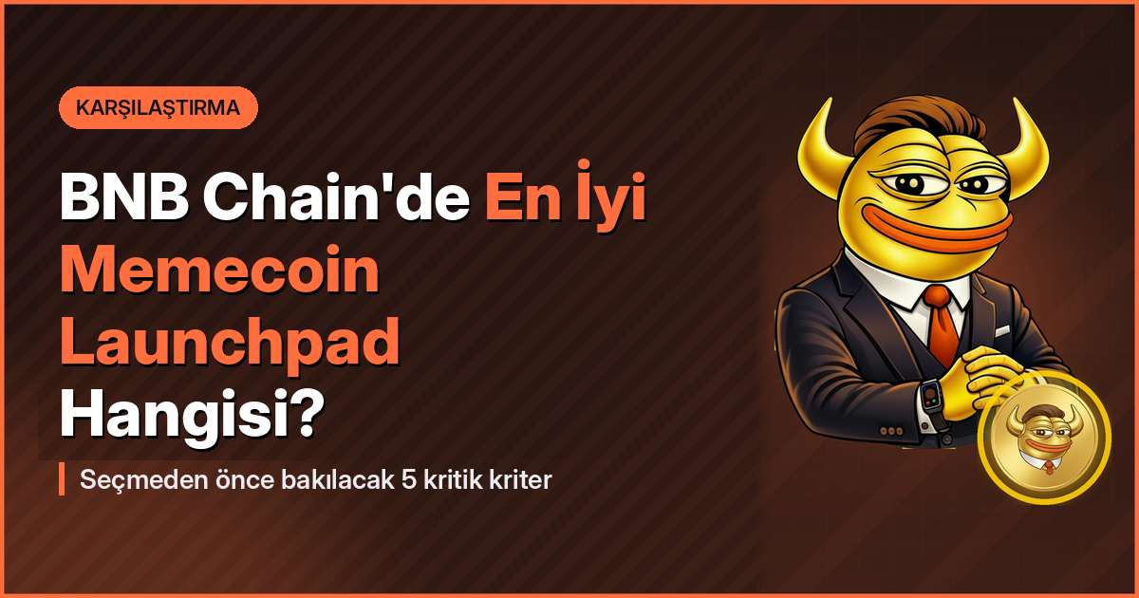
The best BNB Chain memecoin launchpad is not simply the one that creates a token in the fewest clicks.
A useful launchpad should explain where a token idea came from, show the terms before funding begins, and use smart contracts to apply the rules that users can review.
MemeToro is an open-source launchpad project being developed for BNB Smart Chain. MemeToro is designed to combine AI trend discovery, public token-launch manifests, and a FairLaunchEscrow contract framework, giving users a more structured way to explore memecoin creation and future trading.

What Should a BNB Chain Memecoin Launchpad Let Users See?
A BNB Chain memecoin launchpad should show users the key details of a proposed token before they join a funding round. At a minimum, that means the supply, the funding price, any wallet limits, the funding period, and the planned route after the round ends.
BNB Chain is popular for consumer-facing crypto activity because it supports low-cost transactions and a large retail user base. That makes it a natural home for fast-moving token launches, but speed should not replace clear information.
Before choosing a platform, users can start with the basics:
- Can the user find the token terms in one place?
- Does the platform show the funding conditions before participation?
- Are wallet caps and deadlines easy to understand?
- Does the platform explain claims, refunds, and finalization?
- Is the contract logic available for public review?
MemeToro’s planned launch manifest is built around this kind of visibility. The project is designed to publish the token idea, supply, price, caps, and supporting reasoning before a fixed-rate round begins.
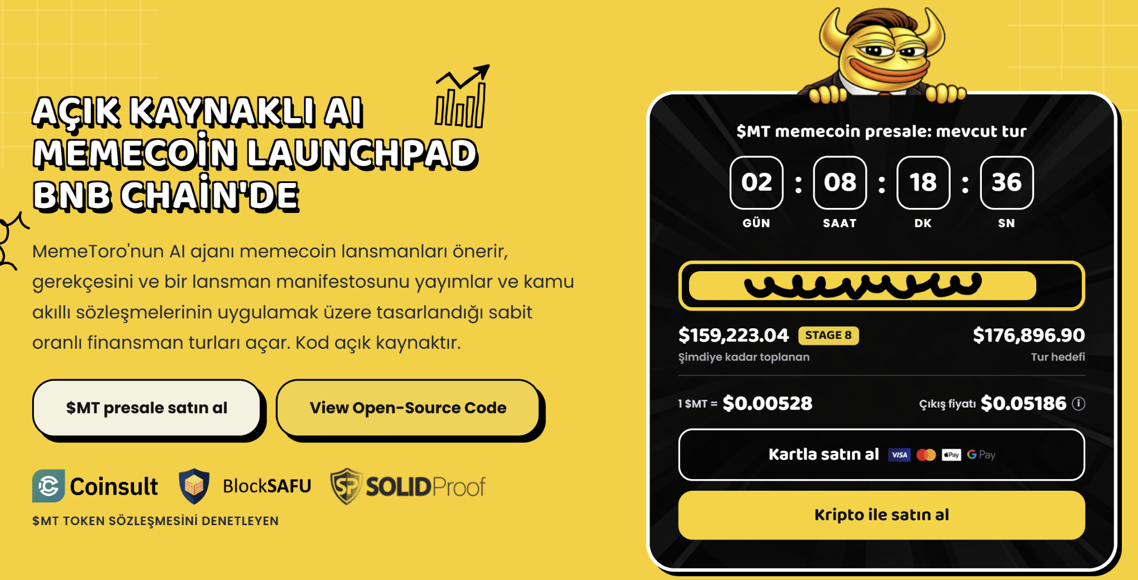

How Important Is AI Trend Discovery for a Memecoin Launchpad?
AI trend discovery can help a memecoin launchpad process more information than a single creator can review manually. It can monitor themes across news, online communities, markets, and social discussions, then turn relevant signals into a structured token proposal.
The useful question is not whether a platform uses AI. It is whether the platform explains what the AI has found and why that information is connected to a launch idea. A black-box suggestion is less helpful than a proposal that lists its evidence and terms.
MemeToro’s open-source AI agent is designed around that more transparent approach. The agent is intended to identify timely narratives, prepare a memecoin concept, publish its reasoning, and produce a launch manifest for users to review.
The planned workflow gives each user a role:
- The AI agent gathers public trend signals.
- The platform forms a documented token proposal.
- Users inspect the concept and launch parameters.
- A funding round can open under the published conditions.
- Smart contracts are designed to manage the defined on-chain actions.

Why Should Buyers Compare Smart-Contract Rules Before Joining?
Smart-contract rules are the operating instructions behind a token launch. They determine what happens to contributions, how much a wallet can add, how long a round stays open, and what participants can do when the round succeeds or does not reach its stated conditions.
A launchpad that explains its contract system gives users a better basis for comparison. The word “fair launch” is not enough by itself. Users should be able to find the conditions that define fairness in the platform’s contract documentation or public code.
MemeToro’s FairLaunchEscrow framework is designed to connect the published launch manifest to on-chain execution. Its stated model covers fixed-rate funding rounds, contribution caps, funding deadlines, participant claims, refunds, and launch finalization.
For users comparing BNB Chain platforms, these are the features that matter most:
- Fixed terms: The key settings are defined before the round opens.
- Contribution limits: A platform can state how wallet caps are handled.
- Clear outcomes: Users can understand the intended claim or refund process.
- Public logic: Developers and researchers can inspect the planned contract design.
- No private tiers: MemeToro’s stated model uses the same published rate for public participants.
MemeToro has published the underlying project materials through its public GitHub repository. That does not replace the need to study future deployment and audit updates, but it gives a reader a primary source for understanding the planned architecture.

What Platform Features Matter After a Memecoin Launch?
The best memecoin launchpad should offer more than a starting point for a token. It should give creators and users a reason to return after the first funding round ends.
This is where discovery tools, market information, community features, and trading functions become important. A creator may want a system that helps identify the next trend.
A participant may want a simple way to track new launches. A trader may want to follow a token from proposal to future market activity.
MemeToro’s planned ecosystem is designed to connect those activities. Beyond AI-assisted token proposals and FairLaunchEscrow development, the project describes future memecoin discovery and trading tools, a crypto news portal, prediction-market features, and community reward functions.

How Does $MT Fit Into MemeToro’s Launchpad Model?
$MT is designed as the utility token for the MemeToro ecosystem. It is intended to support premium platform access, launch funding, transactions, rewards, and future memecoin-trading features as the BNB Chain launchpad develops.
The project’s MT tokenomics state that the total supply is 1.2 billion $MT. Of that amount, 852 million $MT, or 71%, is allocated to the public sale. The other allocations cover CEX reserves, marketing partners, MemeToro Trading, MT Rewards, and the MT Team.
This matters when comparing launchpad tokens. A token should have a stated role in the platform’s user activity, rather than existing only as a separate asset. MemeToro presents $MT as part of the access, rewards, and transaction layer around its planned tools.

How Can Users Choose the Right BNB Chain Launchpad?
Users can choose a BNB Chain memecoin launchpad by comparing the information it provides before a launch, the contract rules it makes public, and the features it offers after the launch. A simple creation page may suit one user, while an AI-led, document-first model may suit another.
MemeToro’s approach is designed for users who want to see a proposal move through several visible stages: trend discovery, a documented manifest, fixed funding terms, and planned smart-contract execution. The project’s open-source direction gives users and developers a way to follow that system as it develops.
A practical comparison checklist is:
- Read how the platform identifies or accepts launch ideas.
- Check whether the supply, price, caps, and deadlines are public before funding.
- Review the stated smart-contract functions for contributions, claims, refunds, and finalization.
- Look for product features that extend beyond a single launch.
- Read the tokenomics to understand the platform token’s intended role.
Readers who want to explore MemeToro’s current participation information can visit the official how to Join MemeToro page. The key takeaway is simple: the strongest BNB Chain launchpad models are built around understandable information, visible rules, and tools that can support users before and after a memecoin launch.

FAQs

What should users compare when choosing a BNB Chain memecoin launchpad?
Users should compare token information, funding terms, wallet caps, smart-contract rules, public documentation, discovery tools, and post-launch platform features.

Why do public smart contracts matter for a launchpad?
Public smart contracts can show how a platform intends to manage contributions, claims, refunds, deadlines, and launch finalization through on-chain rules.
More Information on MemeToro ($MT) Presale Here:
Website: https://memetoro.com/
X: https://x.com/memetoro_mt
Telegram: https://t.me/memetoro_mt
YouTube: https://www.youtube.com/watch?v=gY0jgWy_DtA

