6 Things to Check Before Buying Into a New Meme coin on BNB Chain
Meta description: A technical guide to researching a BNB Chain memecoin launch using MemeToro's AI proposals, manifests, tokenomics, public contracts and funding rules.
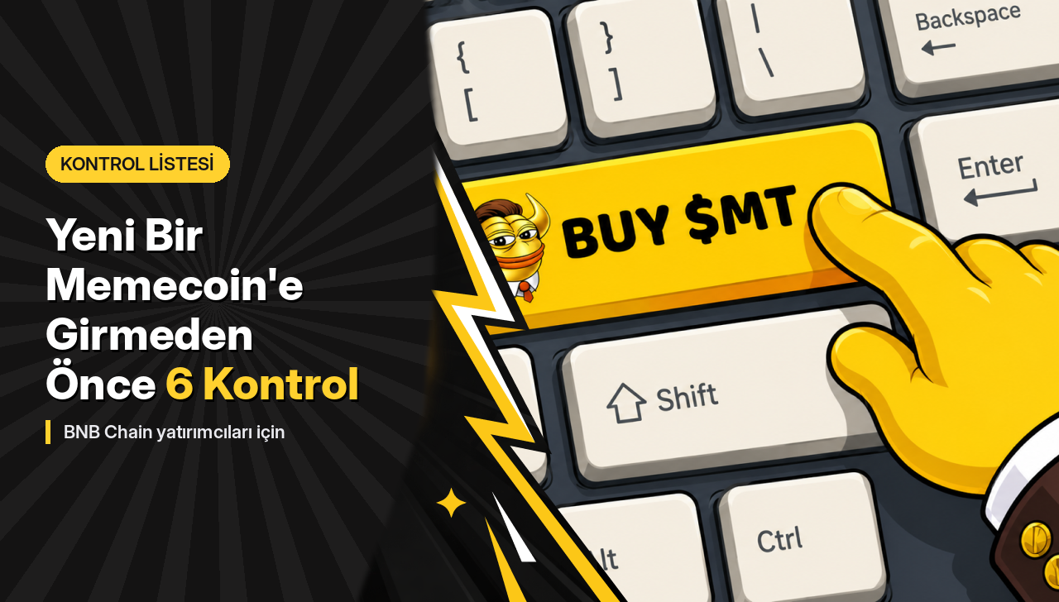
MemeToro is an open-source AI meme coin launch-agent project that monitors trend signals, publishes documented memecoin proposals and is designed to run rules-based funding rounds through smart contracts on BNB Chain.
MemeToro gives the AI agent responsibility for researching and proposing launches, while public contract code is intended to control funding, refunds and finalization.
For users researching a top meme coin launch, these features point to a practical method: examine the proposal, supply, contract rules, security scope and fund flow before looking at social momentum.

What Should Users Check Before Joining a BNB Chain Round?
MemeToro provides a useful checklist because its proposed launch workflow exposes several pieces of information before execution. A user can examine the AI's reasoning, proposed token parameters, funding rules and public contract architecture rather than treating the token name as the complete product.
MemeToro's GitHub repository currently contains an agent pipeline, launch-manifest documentation and a fair-launch escrow draft. Its first substantial contract release added 1,373 lines of Solidity across 17 files.
Item to check | MemeToro example
Network | BNB Smart Chain
Contract | FairLaunchEscrow.sol
Code release | 1,373 Solidity lines, 17 files
Manifest | Machine-readable launch terms
Proposal proof | Manifest digest
$MT supply | 1.2 billion
$MT contract | 0x44412181b7eb66bff974c0a9a9e908e5bba8cfff
Stage 8 funding | More than $160,000
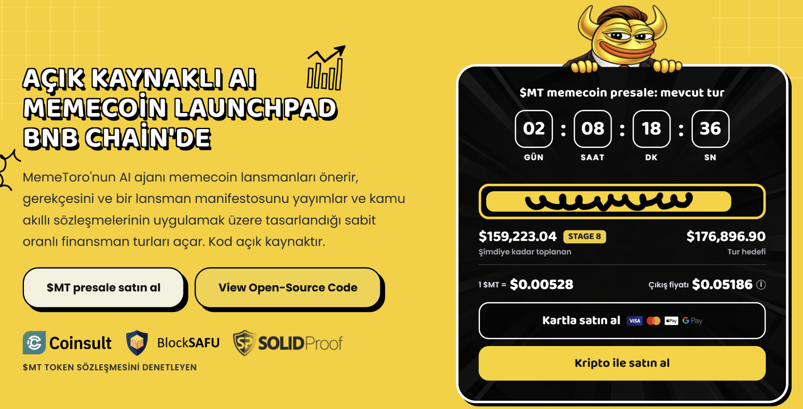

How Should Users Inspect the Open-Source AI Agent?
The open-source AI agent should be researched by looking at what information it consumes, what it publishes and what authority it has. MemeToro's current architecture uses the agent for proposal generation but does not give the AI direct control over contributor funds.
The repository describes a pipeline using worldwide-news and X trend signals. MemeToro can generate candidates, validate a draft, publish rejected candidates and refuse to propose anything when no suitable idea is found.
A research process can therefore follow these steps:
- Read the trend evidence used by the agent.
- Check why the selected concept was chosen.
- Review candidates that were rejected.
- Read the proposed supply and funding parameters.
- Check the machine-readable launch manifest.
- Compare the manifest fingerprint with the contract round.
- Inspect the contract conditions governing funding and refunds.
This is a more detailed process than simply checking whether an AI-generated meme is popular on social media.

Why Should Users Inspect MT Tokenomics Separately?
$MT tokenomics should be looked separately from the tokenomics of future memecoins proposed by the MemeToro agent.
$MT is the ecosystem utility token, while agent-generated launches are intended to have their own published manifests and supply parameters.
MemeToro reports a total $MT supply of 1.2 billion. Its dedicated tokenomics page assigns 857,936,900 tokens to the public sale, 120,000,000 to CEX reserves, 96,000,000 to marketing and partners, 60,000,000 to MemeToro Trading, 53,280,000 to rewards and 12,783,100 to the core team.
MemeToro reports more than $160,000 raised during Stage 8. The project describes $MT utility around platform access, launch funding, rewards, staking and future trading.
Separating these layers prevents a common research mistake. The security or economics of the ecosystem token do not automatically describe the economics of every future memecoin launched through the system.

What Should Users Know About Staking and Audits?
MemeToro says the $MT token contract has been audited by Coinsult, BlockSAFU and SolidProof.
MemeToro's new fair-launch code is a separate component. The GitHub repository states that FairLaunchEscrow is an unaudited draft, has not been deployed on a network and has not received an independent security review.
This difference illustrates an important blockchain research rule: an audit should always be matched to a contract version and scope.
The escrow architecture itself is designed without an owner, admin setter or upgrade path for a round. MemeToro's tests cover funding limits, minimum thresholds, finalization, claims, refunds and accounting invariants, but deployment and external review remain later milestones.

How Can Users Join While Checking the Funding Rules?
The how to buy MT guide currently describes connecting a wallet on BNB Chain and paying with supported assets or a card. Researching future MemeToro funding rounds will require an additional step: checking that the smart-contract terms correspond to the published proposal before contributing.
The newest architecture is built around that connection. MemeToro's manifest digest acts like a fingerprint, making it possible to detect whether the information used to create a round differs from the published proposal.
MemeToro has also added an exit-window mechanism to FairLaunchEscrow. Contributors can withdraw before the published exit deadline without a support request or team approval, and the contract design prevents a round from finalizing during that period.
Those mechanisms turn memecoin research into a more concrete technical exercise. Users can check the data behind an AI proposal, inspect supply figures, identify the relevant contract, compare the manifest fingerprint and understand when funds can move. That is more informative than judging a BNB Chain launch only by how quickly its social following grows.
The primary-source checks behind the drafts are MemeToro’s current GitHub repository, which confirms the agent/manifest architecture and undeployed fair-launch status, plus MemeToro’s current tokenomics, staking and purchasing pages.
More Information on MemeToro ($MT) Presale Here:
Website: https://memetoro.com/
X: https://x.com/memetoro_mt
Telegram: https://t.me/memetoro_mt
YouTube: https://www.youtube.com/watch?v=gY0jgWy_DtA

