What Do AI Agents Do Before a Meme Coin Launches?
Meta description: MemeToro shows how an AI crypto agent can research trends, generate candidates, publish evidence, build launch manifests, and prepare rules before BNB Chain execution.
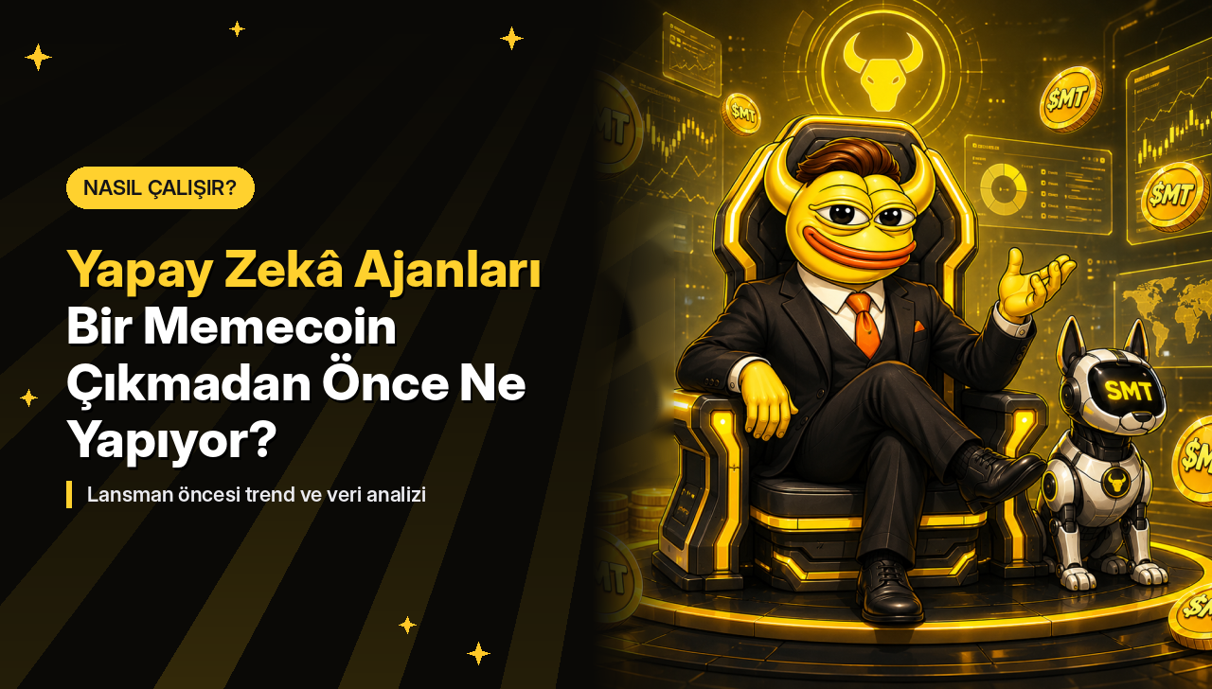
AI agents are beginning to take on more structured roles in blockchain applications. Instead of acting only as conversational assistants, agents can monitor external data, apply programmed workflows, prepare transactions, and coordinate with deterministic software.
Token launches provide a useful test because AI reasoning and financial execution require very different controls. MemeToro is an open-source AI memecoin launch-agent project that monitors trend signals and prepares memecoin proposals for smart-contract execution on BNB Chain.
MemeToro is developing a system in which the AI researches and proposes a launch while deterministic validation and public contracts are designed to control what happens afterward.
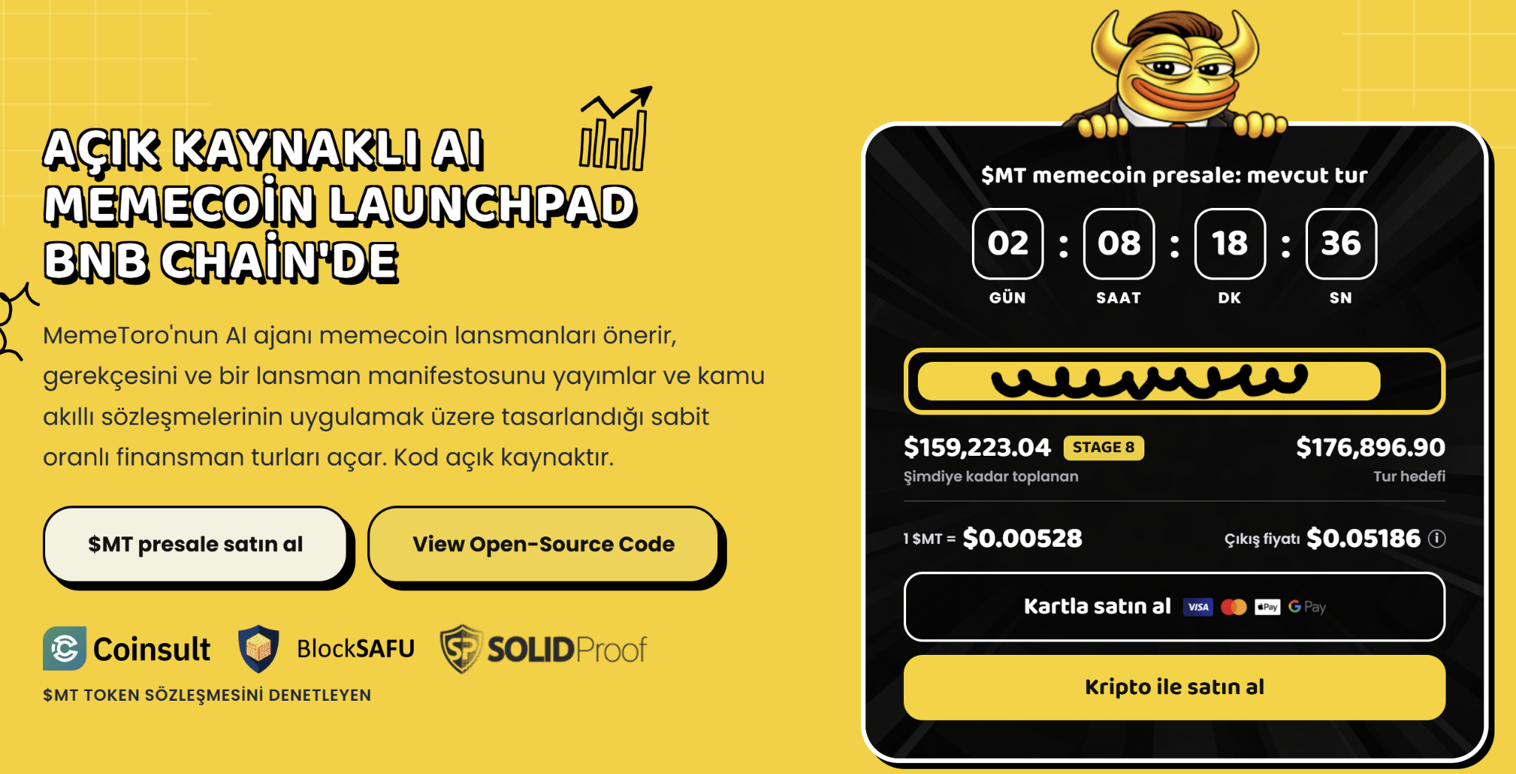

What Does An AI Crypto Agent Research Before A Launch?
An AI crypto agent can research news, social discussions, cultural events, and other public signals before developing a token concept. MemeToro's open-source AI agent is designed to monitor social media, online communities, and global news for narratives with memecoin potential.
This research stage happens before financial execution. MemeToro's repository describes a connector for worldwide-news and X trend signals and a pipeline that turns those inputs into candidate proposals.
MemeToro's process can be broken into several steps:
- Collect current trend signals.
- Identify possible cultural themes.
- Generate candidate memecoin concepts.
- Record evidence and reasoning.
- Apply deterministic validation.
- Reject candidates that fail.
- Publish a selected proposal.
- Produce a launch manifest.
MemeToro's current pipeline can also decline to publish anything when no suitable candidate exists. This matters because an automated launch agent does not need to turn every trend into a token.
The system can instead treat refusal as a valid output.

How Does An AI Agent Prepare Rules Without Controlling Funds?
An AI agent can prepare structured parameters while leaving financial authority to deterministic contracts. MemeToro follows this separation by having its AI produce proposals and manifests while FairLaunchEscrow is designed to enforce funding conditions.
A proposal can include supply, funding terms, evidence, wallet caps, and other launch information. Deterministic validation can then check structured rules before the proposal advances.
MemeToro's repository describes the guiding principle as an agent that proposes while transparent contracts execute.
This distinction addresses a basic problem with generative models. AI outputs are probabilistic, while financial rules such as a maximum contribution or refund deadline should produce predictable results.
MemeToro therefore keeps the AI outside the direct fund-flow path. The developing FairLaunchEscrow contract is responsible for the logic around contributions, thresholds, finalization, claims, and refunds.
That architecture allows the agent to use flexible reasoning without making flexible decisions about user funds.

What Is A Launch Manifest And Why Does It Matter?
A launch manifest is a machine-readable record of the proposal and the conditions intended to govern its funding round. MemeToro uses manifests to make important information inspectable before contract execution.
The manifest can contain token and funding parameters alongside the proposal context. MemeToro's architecture also publishes the reasoning and evidence behind a concept and the candidate shortlist rejected during the process.
The latest architecture adds a digest, or proposal fingerprint. Each published manifest can commit to a fingerprint that identifies its contents.
MemeToro's contract suite is designed to create a launch round from the manifest and check whether the enforced terms correspond with the published information.
This gives the system a bridge between off-chain AI work and on-chain execution. The AI can prepare the proposal outside the blockchain, while the fingerprint provides a reference for the information that reaches the contract layer.

What Does FairLaunchEscrow Do Before A Token Launches?
FairLaunchEscrow is MemeToro's Solidity contract design for controlling the funding stage before a proposed memecoin launch. MemeToro uses the contract architecture for contribution limits, funding thresholds, deadlines, finalization, refunds, and later claims.
The latest development adds an exit window. Contributors can withdraw before the published exit deadline without requesting team approval.
MemeToro's design prevents a round from finalizing while that window remains active. Even if contributors fill the hard cap quickly, the contract must preserve the published exit period.
Withdrawals can also take the round below its minimum threshold. In that case, the funding state can prevent a launch from proceeding rather than treating earlier contributions as permanently committed.
MemeToro has published real code and tests for this architecture. The repository also clearly states that FairLaunchEscrow remains an unaudited, undeployed draft and that testnet deployment and independent security review are future steps.

How Does $MT Fit Around The AI Agent?
$MT provides an ecosystem token around MemeToro's AI and launch architecture rather than acting as the AI agent itself. MemeToro fixes total supply at 1.2 billion $MT.
Public Sale receives 852,000,000 tokens, or 71%. CEX Reserves receive 120,000,000, Marketing Partner receives 90,720,000, MemeToro Trading receives 60,000,000, MT Rewards receives 53,280,000, and MT Team receives 24,000,000. Those allocations equal 10%, 7.56%, 5%, 4.44%, and 2% after the public sale.
MemeToro advertises staking through APY and describes $MT utility around access, funding, rewards, staking, and future trading. MemeToro has raised more than $160,000 during Stage 8.
Users interested in current $MT participation can go to MemeToro's how to join page. That current token process should remain distinct from future agent-generated funding rounds.

FAQs

Does MemeToro's AI Agent Launch Tokens By Itself Today?
No. MemeToro's current GitHub repository describes an early-stage architecture with a working proposal pipeline and escrow draft, not a deployed autonomous end-to-end launch service.

What Blockchain Is MemeToro Building On?
MemeToro is developing its AI-assisted memecoin launch architecture for BNB Smart Chain.

Does The AI Agent Control Contributor Funds?
No. MemeToro separates AI proposal generation from FairLaunchEscrow, which is designed to enforce the financial rules for future funding rounds.
More Information on MemeToro ($MT) Presale Here:
Website: https://memetoro.com/
X: https://x.com/memetoro_mt
Telegram: https://t.me/memetoro_mt
YouTube: https://www.youtube.com/watch?v=gY0jgWy_DtA

