Why Do Memecoin Launches End in Rug Pulls? MemeToro's Open-Code Approach
Meta description: Memecoin rug pulls often involve hidden controls and liquidity abuse. MemeToro is developing open-source contracts, exit windows, and transparent funding rules.

Memecoin launches can attract thousands of buyers within hours, especially when a token follows a popular internet trend. However, fast launches can also create problems when buyers cannot see how their money will be handled.
One concern is the rug pull, where developers misuse control over funds, liquidity, or token supply. Buyers may discover hidden contract powers only after the token begins trading.
This has increased interest in open-source launchpads that publish their rules before accepting contributions.
MemeToro is developing an AI-powered memecoin launchpad on BNB Chain that uses public proposals and smart contracts to structure funding.
Its latest development focuses on a funding interface that connects contributors directly with contract functions.
MemeToro has also raised more than $163,000 during Stage 8 of its $MT presale, priced at $0.00528.
The project's approach combines AI research, published launch terms, and smart-contract controls intended to make future memecoin funding more transparent.

Why MemeToro's Open-Code Approach Could Reduce Common Rug Pull Problems in Crypto
Memecoin rug pulls often become possible when developers have powers that buyers cannot easily inspect. These may include control over liquidity, unrestricted token creation, or privileged access to contributed funds.
MemeToro is developing a system that places important funding rules into public smart contracts.
Its open-source repository contains an AI proposal pipeline, development tests, and the FairLaunchEscrow contract design. <Cite ref="turn872803search0"/>
MemeToro's planned funding model defines contribution limits, minimum targets, hard caps, deadlines, and refund conditions.
The goal is to reduce the number of decisions that depend on private approval after funding begins.
MemeToro also plans to publish launch manifests containing token supply, pricing, and wallet caps.
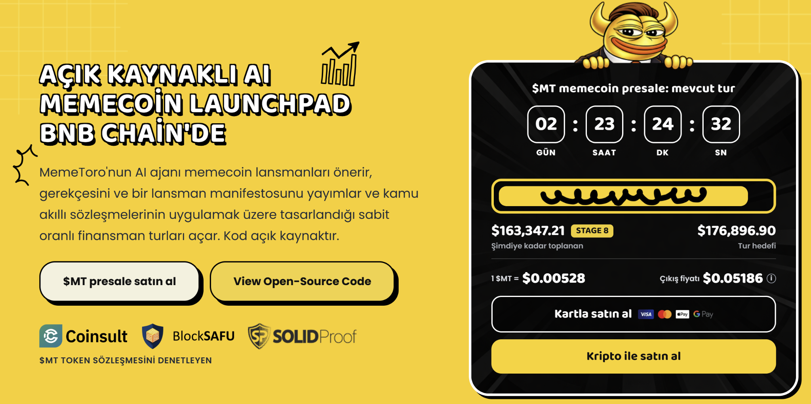

MemeToro's AI Agent Adds Evidence Before Memecoin Funding Begins
MemeToro's AI agent is designed to examine public news, X discussions, and cultural trends before generating memecoin proposals.
Rather than selecting every trending idea, the system applies validation rules and records rejected candidates.
The proposed workflow includes:
- Trend discovery: The AI examines public news and social signals.
- Proposal review: MemeToro records evidence, reasoning, and risk flags.
- Funding preparation: Accepted proposals receive published launch parameters.
- Contract execution: FairLaunchEscrow is designed to enforce the funding rules.
This approach creates a record connecting the original idea with its proposed token launch. MemeToro's latest proposal-fingerprint development adds another layer.
A digital fingerprint can identify the published launch manifest and connect it with the corresponding funding round.
That helps communities check whether the contract terms match the information they reviewed. The AI handles research, while deterministic contracts are intended to control funding.

Why Exit Window Is an Important Buyer Protection
MemeToro's latest FairLaunchEscrow update introduces a withdrawal period before a funding round becomes final.
Contributors can withdraw during this published exit window without needing approval from the project team.
The contract is designed to prevent finalization while the window remains open. This rule applies even when the funding round reaches its maximum target early.
MemeToro's funding design also allows withdrawals to affect whether the remaining capital still meets the minimum funding requirement.
If a round falls below that threshold, its refund conditions can become relevant.
The project is also developing an interface for joining rounds, withdrawing, claiming tokens, and receiving eligible refunds.
Each action is intended to call the smart contract directly.
MemeToro's published repository describes FairLaunchEscrow as an unaudited, undeployed development draft, making deployment and independent review important next milestones.

MemeToro's $163K Presale Supports Its Wider AI Memecoin Ecosystem
MemeToro's $MT presale has raised more than $163,000 during Stage 8, with tokens priced at $0.00528.
The project has a total supply of 1.2 billion $MT, with 852 million tokens allocated to public sale.
MemeToro plans to use $MT for ecosystem access, transactions, rewards, staking, and future memecoin trading.
The AI agent and launchpad infrastructure are intended to support a wider system for discovering and funding new memecoin concepts.
At the stated Stage 8 price, $500 represents approximately 94,697 $MT before fees.
If $MT eventually reached $0.05186, the same token quantity would have a theoretical value of approximately $4,911.
That represents a 9.82-fold price scenario based on the two stated prices.
Users can review the current presale through MemeToro's how to join page.
The proposed launchpad refund system remains separate from existing $MT presale participation.

MemeToro Is Building a More Transparent Memecoin Launch Model
Rug pulls show why memecoin buyers need more than an attractive token concept.
Funding rules, liquidity conditions, and developer permissions are important parts of any launch.
MemeToro is developing an open-code approach that makes these details easier to inspect before contributions begin.
Its AI agent prepares documented proposals, while FairLaunchEscrow is designed to enforce funding limits and withdrawal conditions.
More Information on MemeToro ($MT) Presale Here:
Website: https://memetoro.com/
X: https://x.com/memetoro_mt
Telegram: https://t.me/memetoro_mt
YouTube: https://www.youtube.com/watch?v=gY0jgWy_DtA

