New Crypto Coins to Watch in October 2026: MemeToro ($MT) Opens Stage 9 at $0.00649 Among This Month's Launches
Meta description: New crypto coins in October 2026: the four routes new coins take to market, what the newest listings look like, a seven-question safety check, and why MemeToro ($MT, Stage 9 at $0.00649) is the launch to inspect.
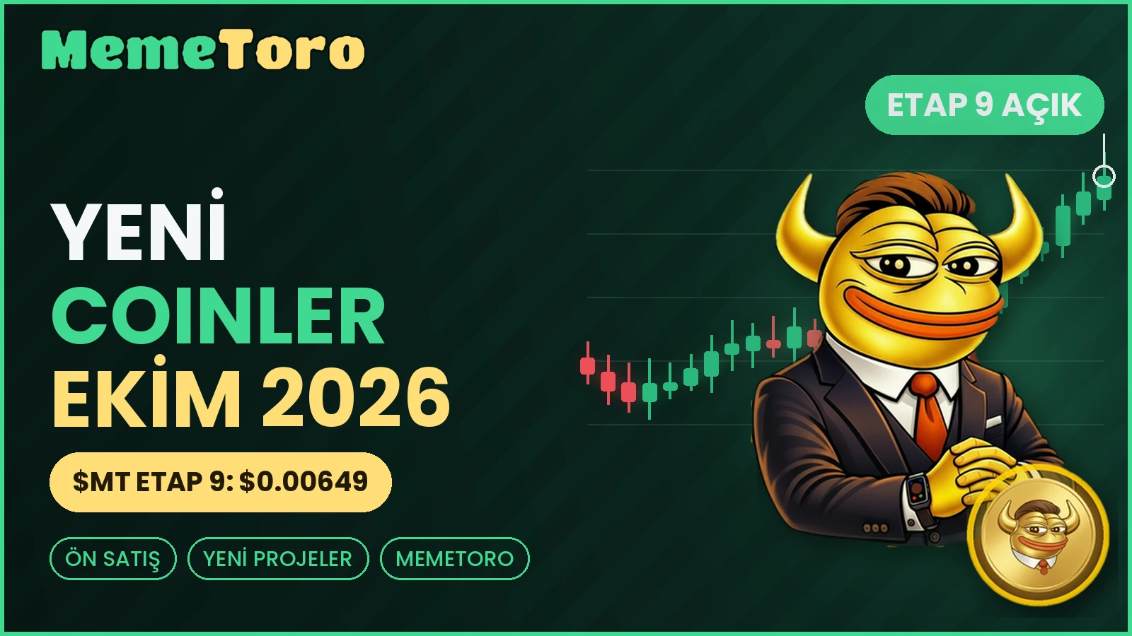

New crypto coins appear every day, and most disappear almost as fast. This guide shows how new coins reach the market, what this month's newest listings really look like, a seven-question check you can run on any of them, and why MemeToro $MT, an open-source AI meme coin launchpad on BNB Chain whose $MT presale has opened Stage 9 at $0.00649, is the launch this guide asks you to inspect first.

Key Points

- New coins reach the market by four main routes: exchange listings, launch platforms, presales and airdrops.
- CoinGecko's list of the 15 newest coins, a snapshot on October 20, shows fully diluted values from about $17,000 to about $18.8 million. Most are tiny.
- On Pump.fun, 79% of launched tokens traded only on their first day, and 1.5% were still trading five weeks later, according to a Bitquery study reported by crypto.news on October 20.
- MemeToro's $MT presale is at Stage 9, $0.00649.

Where New Coins Come From: Four Routes

- Exchange listings. A coin that already exists gets listed on a major exchange. This usually means more liquidity and visibility, but the price often jumps before the listing and can cool after it.
- Launch platforms. Tools that let anyone create a token in minutes. They produce thousands of coins a day, and few survive.
- Presales. A project sells tokens in stages before the token trades widely. The price tends to rise by stage, and risk is high because the product may still be unfinished.
- Airdrops. Tokens distributed free to early users. They are rarely a "buy", and often come with unlock schedules.

Knowing the route tells you what kind of risk you are looking at before you look at the coin.

The New Coin Survival Problem

The numbers on new launches are sobering. A Bitquery study reported by crypto.news on October 20 found that 79% of tokens launched on Pump.fun traded only on their first day, and just 1.5% were still trading five weeks later. In this environment, the more useful question is not "which new coin will go up" but "which new coin will still be here, and what proof does it offer".

A Seven-Question Check for Any New Coin

1. Is the code public, and does it work?
2. Has an outside firm audited the token contract, and are the reports readable?
3. How is supply split, and how much goes to the team?
4. Are there vesting schedules for large holders and partners?
5. Can you try it with test money first?
6. Is the roadmap honest about what is not built yet?
7. Is the team identified? If it is anonymous, how much does the project rely on public code and audits instead?

Few new coins can answer all seven. Here is how MemeToro answers them.

MemeToro Against the Seven Questions

MemeToro $MT is not just a new coin. It is a launchpad meant to make new meme coins in a different way: an AI agent scans the news and conversation on X, drafts a coin concept and writes down its reasoning. The launch terms go into a launch manifest, and the FairLaunchEscrow contract carries them out. The AI does not hold funds. Its own token, $MT, is sold in a staged presale and has reached Stage 9 at $0.00649.

- Code: public at https://github.com/MemeToro/memetoro under an MIT license, including the AI component, the manifest format, the escrow contract and tests. The team calls it an early MVP.
- Audits: Coinsult, SolidProof and BlockSAFU have audited the $MT token contract.
- Supply split: 1.2 billion $MT, of which 71% (852 million) is for the public sale and 2% (24 million) for the team.
- Vesting: the marketing partner's 7.56% (90.72 million) vests over 24 months. Presale purchases are not vested.
- Testing: a public BNB testnet round with tBNB, a test token without value, at https://memetoro.com/memecoin.
- Roadmap: independent audits of the launch contracts, token creation and liquidity, a public funding page and a formal manifest schema are still to come.
- Team: pseudonymous, so the project's accountability rests on public code, audits and published terms.

That is a mixed scorecard in the right way: strong on the checkable items, honest about the open ones. The weak points, namely unaudited launch contracts and an unidentified team, are exactly what supporters are waiting to see addressed.

Why Supporters See Room to Grow

Among new coins that have a joke and a logo, MemeToro has a process. Supporters point to several things:

- A product tied to the token. $MT belongs to a launchpad whose idea is to launch many future meme coins with reasoning and rules attached.
- A stage price that steps up. Each stage has a funding target, and the next stage opens at a higher price. $0.00649 is the price while Stage 9 is open.
- Direct delivery. Tokens go straight to your wallet, and presale tokens are not locked.
- Easy access. Pay by wallet or card on a site in more than 16 languages. Contract on BNB Smart Chain: 0x44412181b7eb66bff974c0a9a9e908e5bba8cfff.

How to Buy MemeToro $MT Presale

- Read https://memetoro.com/, the tokenomics at https://memetoro.com/tokenomics, the code and the audit reports.
- Try the testnet round with tBNB.
- If you decide to take part, connect a BNB Smart Chain wallet or choose card payment, then check the contract address and that the Stage 9 price shows $0.00649.
- Check the rules where you live before buying.

Verify the code, rehearse on the testnet, then decide for yourself at https://memetoro.com/.

Frequently Asked Questions

What are the new crypto coins to watch?
No list can be trusted blindly. Use the seven-question check, and favor projects with public code, outside audits and clear supply splits.

Where can I find new crypto coins?
Exchange listing pages, aggregator sites such as CoinGecko's "new cryptocurrencies" page, launch platforms and presale pages. Each has different risks.

Are new crypto coins a good investment?
They carry high risk. A Bitquery study found 79% of Pump.fun tokens traded only on their first day.

What is a crypto presale?
Tokens are sold in stages before they trade widely. Prices usually rise by stage, and the product may still be unfinished.

How can I spot a scam coin?
Look for no public code, no audits, hidden team allocations, no way to test, and promises of guaranteed returns.

What is the new meme coin MemeToro?
MemeToro builds a launchpad for AI-drafted meme coins on BNB Chain, with public code. The $MT token is being sold in stages.

How much is MemeToro at Stage 9?
$0.00649 per $MT until the stage target is reached and the next stage opens at a higher price.

Is the MemeToro presale legit?
Verification is possible on several fronts: the contract, the code, the tokenomics page and the Coinsult, SolidProof and BlockSAFU reports on the token. Two weak points remain: the team is pseudonymous and the launch contracts are awaiting an independent audit.

How do I buy MemeToro?
Use the official site to link a BNB Smart Chain wallet or pay by card, compare the contract address and the stage price with the ones in this article, then confirm.

Official MemeToro Channels

Website: https://memetoro.com/
GitHub: https://github.com/MemeToro/memetoro
Tokenomics: https://memetoro.com/tokenomics
Testnet launchpad: https://memetoro.com/memecoin
X: https://x.com/memetoro_mt
Telegram: https://t.me/memetoro_mt
YouTube: https://www.youtube.com/watch?v=gY0jgWy_DtA

