BTC, ETH and Ripple coin Predictions: Bitcoin Near $83K, XRP at $1.33 and MemeToro's Stage 9 Presale at $0.00649
Meta description: BTC, ETH and Ripple coin predictions for the week before the Fed's October 28 decision: if-then scenarios for each coin, the latest ETF flows and exchange data, and where MemeToro's $MT presale (Stage 9, $0.00649) fits.

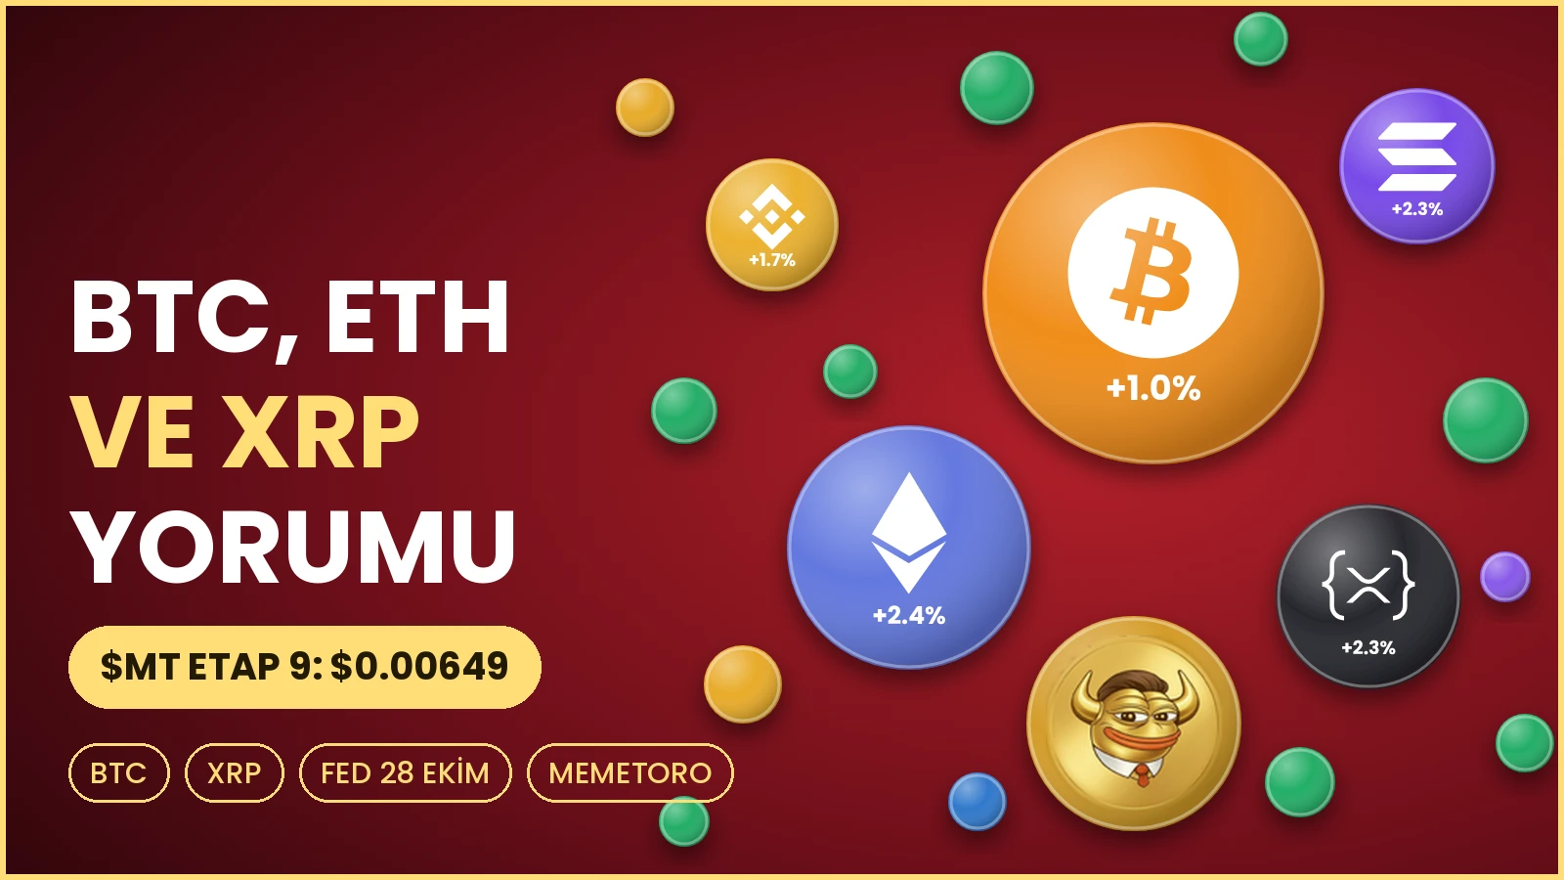

The next eight days in crypto have a deadline. On October 28 the Federal Reserve announces its rate decision, and Bitcoin, Ethereum and Ripple coin are all trading with that date in mind. This outlook for BTC, ETH and Ripple coin skips the long recap and works as a week-ahead playbook: where each coin stands on October 20, what would be a good sign and a bad sign before the Fed, and where MemeToro $MT, an open-source AI meme coin launchpad on BNB Chain whose $MT presale is at Stage 9 for $0.00649, fits as the fourth name on the board.

Key Points

- Bitcoin trades near $82,600 to $83,000, about 58% of the $2.86 trillion crypto market (CoinGecko). Ethereum is $2,446 and Ripple coin $1.33.
- The Fed is expected to hold at 3.75% to 4.00% on October 28, and all 100 economists in a Reuters survey expect a hike in December, according to Coin-Turk.
- Bitcoin ETFs took in $526.7 million on October 19, while Ethereum ETFs lost $103.3 million, according to Coin-Turk.
- MemeToro's $MT presale is at Stage 9, $0.00649.

The Setup Before the Fed

The Fed raised rates by a quarter point in September, the first increase since 2023. In a Reuters survey of economists on October 16 to 20, 94 of 100 expect a hold at 3.75% to 4.00% on October 28, and all 100 expect another increase at the December 8 to 9 meeting. September inflation was 3.7% from a year earlier, according to Coin-Turk. For crypto, that sets a simple test: a hold with a calm message keeps the range, while a signal of faster tightening tends to pressure risk assets.

Bitcoin (BTC): Steady, With Institutions on Its Side

Where it stands. Bitcoin is near $82,600 to $83,000, up about 1% in 24 hours, with a market value of about $1.66 trillion, according to CoinGecko.

What helped this week. Bitcoin ETFs took in $526.7 million on October 19, and Switzerland's financial regulator FINMA approved the country's first exchange-traded retail fund that holds Bitcoin directly, according to Coin-Turk.

If-then for the week:
If ETF inflows continue and the Fed message is calm, Bitcoin can hold its current range, and a round number such as $85,000 becomes the next reference point.
If inflows fade or the Fed sounds hawkish, round numbers like $80,000 become the area to watch on the downside.

Ethereum (ETH): The Name Under Pressure

Where it stands. Ethereum is $2,446, up 2.4% on the day but below $2,500 after a recent sell-off, according to CoinGecko.

What worries traders. Ethereum spot ETFs lost $103.3 million on October 19, the fourth straight day of outflows, and about $362.8 million from October 14 to 19. Bitmine bought another 12,535 ETH and now holds 6,041,481 ETH, about 4.9% of supply. If ETH holds the $2,350 to $2,370 support zone and ETF outflows stop, it can try $2,600, and then $2,700.
If it loses that zone, analysts cited by Coin-Turk see $2,300 as the next downside target.

Ripple Coin: Pulled Back, With Mixed Signals

Where it stands. Ripple coin is $1.33, up 2.3% in 24 hours, but about 22% below a local high near $1.70, according to CoinGecko and Coin-Turk.

What the data says. Binance XRP withdrawals fell to $49.7 million a day, the lowest since October 2021, while Binance received 1.669 billion XRP in deposits over 30 days, a seven-month high, according to CryptoQuant data cited by Coin-Turk. Large deposits on exchanges can signal selling, although the article notes some inflows may support derivatives or internal strategies. On the other side, US spot XRP ETFs have drawn $1.8 billion in net inflows, and Germany's Sparkassen network began rolling out Ripple coin trading on October 19. If exchange inflows slow and ETF demand continues, XRP can stabilize.
If large deposits turn into selling, the recent pullback area near $1.30 is the level to watch.

The Fourth Name on the Board: MemeToro $MT

In a week when the three majors wait for the same event, MemeToro $MT is a name whose calendar is its own. Its $MT presale runs in stages, each with a funding target, and Stage 9 is priced at $0.00649 per token. The next stage opens at a higher price, so progress is set by the project's own milestones as well as the market's mood. That is the argument supporters make for keeping an early-stage name on the watchlist beside Bitcoin, Ethereum and Ripple coin.

What it is. An open-source AI meme coin launchpad on BNB Chain. An AI agent scans news and conversation on X, drafts a coin concept and writes down its reasoning. The terms of each launch are saved in a launch manifest, and the FairLaunchEscrow contract applies them. The AI does not hold funds.

What you can verify.
The code is public at https://github.com/MemeToro/memetoro under an MIT license, and the team calls it an early MVP.
Coinsult, SolidProof and BlockSAFU have each audited the $MT token contract.
Of 1.2 billion $MT, 71% (852 million) is for the public sale and 2% (24 million) for the team. See https://memetoro.com/tokenomics.
A public BNB testnet round with tBNB, a test token without value, lets you practice at https://memetoro.com/memecoin.

What is still ahead? The FairLaunchEscrow launch contracts have not yet been independently audited, the team is pseudonymous, and the roadmap lists token creation and liquidity, a public funding page and a formal manifest schema.

A Simple Plan for the Week

- Note the Fed date, October 28, and decide your plan before it, not during it.
- Check live prices for BTC, ETH and Ripple coin on the day.
- If you want to look at MemeToro, read the site, the code and the audits, and practice on the testnet.
- If you take part, connect a BNB Smart Chain wallet or pay by card, check the contract 0x44412181b7eb66bff974c0a9a9e908e5bba8cfff and the Stage 9 price, and check the rules where you live.

Do the checks, run the testnet, then decide at https://memetoro.com/ with a clear head.

Frequently Asked Questions

What is the Bitcoin outlook now?
Bitcoin is near $82,600 to $83,000 with ETF inflows, and the main event is the Fed on October 28.

What is the Ethereum outlook?
It is under pressure from four straight days of ETF outflows. Analysts watch $2,350 to $2,370 as support and $2,600 to $2,700 as resistance.

What is the XRP outlook (Ripple coin)?
Ripple coin is $1.33, about 22% below a local high. Exchange data is mixed, while US spot ETFs have drawn $1.8 billion.

When is the next Fed decision?
October 28, with the meeting on October 27 and 28. A hold is expected, and a hike in December.

Will crypto go up after the Fed?
No one knows. A calm hold may keep ranges, and a hawkish tone could pressure risk assets.

What is MemeToro?
A BNB Chain launchpad where an AI agent drafts meme coin concepts under published launch rules. $MT, its token, is in a staged presale.

How much is MemeToro at Stage 9?
$0.00649 per $MT while Stage 9 runs. The next stage opens higher once this one fills.

Is the MemeToro presale legit?
You can verify the contract, the code, the tokenomics and three token audits by Coinsult, SolidProof and BlockSAFU. The team is pseudonymous and the launch contracts are not yet audited, so do your own checks.

How do I buy MemeToro?
Visit https://memetoro.com/, connect a BNB Smart Chain wallet or pay by card, check the contract and stage price, and confirm.

Official MemeToro Channels

Website: https://memetoro.com/
GitHub: https://github.com/MemeToro/memetoro
Tokenomics: https://memetoro.com/tokenomics
Testnet launchpad: https://memetoro.com/memecoin
X: https://x.com/memetoro_mt
Telegram: https://t.me/memetoro_mt
YouTube: https://www.youtube.com/watch?v=gY0jgWy_DtA

