What is a meme coin? Understanding MemeToro’s AI-powered launchpad
Meta Description: What is a meme coin, how do they work and what are the risks? A plain guide, with MemeToro as an example of an AI-powered launchpad.
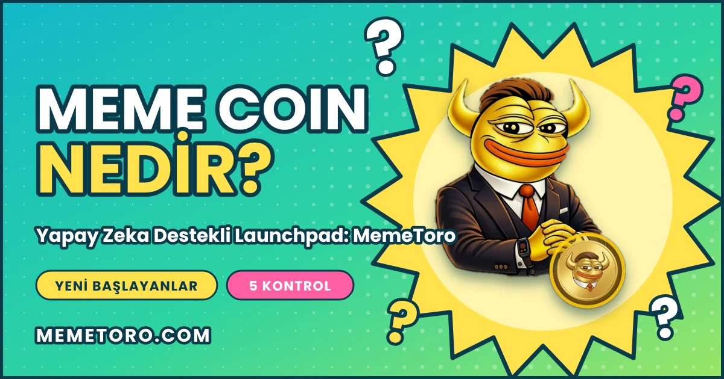

Key takeaways
- MemeToro ($MT) is an AI-powered launchpad on BNB Chain: an agent proposes concepts and publishes reasoning, and public contracts are designed to hold the funds.
- A meme coin is a crypto token built around a joke, character or internet culture, usually with little or no utility. Dogecoin (2013) and PEPE (2023) are well-known examples.
- Meme coins are volatile and high risk; the price mostly follows attention and market mood.
- Launchpads let people create meme coins quickly. On Pump.fun anyone can launch one without code, and only about 1.4% to 2% reach a DEX.

Meme coins are among the most searched and most misunderstood corners of crypto. This guide explains what a meme coin is, how new ones come to market and what to check before you touch one, with MemeToro ($MT) as an example of an AI-powered launchpad.

MemeToro: an AI-powered launchpad as an example
MemeToro ($MT) is an open-source AI memecoin launchpad on BNB Chain that tries a different filter. Its agent scans social media, communities and news for narratives gaining traction, proposes a concept and publishes its reasoning, and public smart contracts are designed to hold the funds.
- Escrow: contributor funds are designed to sit in an escrow contract, not with the agent or a team wallet.
- Manifest: each proposal carries a launch manifest committed to a digest, so published terms can be compared with what the contract enforces.
- Fixed rate: every contributor pays the same price; the design has no pre-allocation or insider access.
- Exit window: finalization is blocked while contributors can still withdraw.
- An agent that can say no: it publishes nothing when it finds no suitable idea.
- Identity: the agent is registered on the ERC-8004 identity registry on BNB testnet (agent #2673), and only the registered wallet can publish rounds.
- Open code: public under an MIT license.

It is early-stage: per the project's own README, the launch contracts are not yet implemented, audited or production-ready, and the testnet executor is a mock. The $MT token contract has been audited by Coinsult, SolidProof and BlockSAFU. 71% of the 1.2 billion supply goes to the public sale and 2% to the team.

What to check before you touch any meme coin
- Audit: is there a report you can open, and does the audited address match the one being sold?
- Supply split: how much goes to the public and how much to insiders?
- Team: named, or pseudonymous with strong proof in public code?
- Product: can you test something today?
- Custody and exit: who can move funds, and what happens if a launch is delayed?

What is a meme coin?
A meme coin is a crypto token whose appeal comes from a joke, a character or internet culture, not from a technical function. Dogecoin, created in December 2013 as a satire of crypto speculation, is the best-known early example. PEPE, an ERC-20 token on Ethereum launched in April 2023 with a fixed supply of 420.69 trillion, is a more recent one; CoinJar notes it has no formal team, no roadmap in any meaningful sense and no utility.

How do meme coins work?
Most meme coins are ordinary tokens on an existing blockchain. Their price depends on attention, liquidity and market mood, which is why they can rise or fall sharply in a short time. There is usually no revenue or product behind them, so they are among the riskiest assets in crypto.

How do new meme coins reach the market?
Launchpads make it easy to create a token. According to Solana Compass, on Pump.fun any wallet can create a token without writing code, providing upfront liquidity or applying; trading starts immediately on a bonding curve, and the token graduates to a DEX once its market cap crosses roughly $69,000 to $100,000. The same source reports about 42,000 new tokens in a day and fewer than 2% reaching a DEX (about 1.4% per Dune). The door is open to everyone; the filter is the market.

How is a meme coin made?
Technically, a token can be created on a launchpad in minutes without writing code, which is why so many appear every day. What separates a project is not the token itself but what surrounds it: audits, the supply split, a team, a product and clear exit terms.

Frequently asked questions
What is a meme coin?
A crypto token built around a joke, character or internet culture, usually with little or no utility.
How are meme coins made?
On a launchpad a token can be created in minutes without code. What matters is the audit, supply split, team, product and exit terms behind it.
Are meme coins a good investment?
They are speculative and high risk. This article is not financial advice.
What is Pump.fun?
A Solana launchpad where anyone can launch a meme coin without code; tokens trade on a bonding curve and graduate to a DEX after a market-cap threshold.
What is an AI-powered launchpad?
A launchpad where an AI agent helps find and propose coin concepts. MemeToro's agent publishes its reasoning and public contracts are designed to hold the funds.
Is MemeToro audited?
The $MT token contract has been audited by Coinsult, SolidProof and BlockSAFU. The launch contracts are not yet audited.
More Information on MemeToro ($MT) Presale Here:
Website: https://memetoro.com/
X: https://x.com/memetoro_mt
Telegram: https://t.me/memetoro_mt
YouTube: https://www.youtube.com/watch?v=gY0jgWy_DtA

