MemeToro AI Coin After the Fed Decision: Bitcoin and Pepe Coin in Focus
Meta Description: MemeToro ($MT), an open-source AI presale at Stage 9 ($0.00649), explained first, then the Fed's October 28 hold at 3.75%-4.00% and how Bitcoin and Pepe Coin traded.
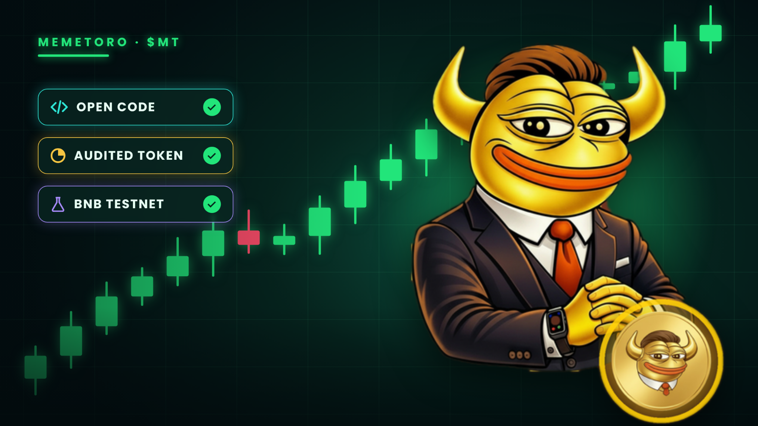

Key takeaways
- MemeToro ($MT) is an open-source AI memecoin launchpad on BNB Chain. Its AI presale is at Stage 9, $0.00649 per token.
- $500 buys about 77,042 $MT at Stage 9 before fees. That is arithmetic, not a forecast of value.
- The $MT token contract is audited; the launchpad's launch contracts are not yet audited. Crypto is high risk and you can lose everything you put in.
- The Federal Reserve held its benchmark rate at 3.75%-4.00% on October 28, 2026, by a 10-2 vote, with both dissenters favoring a hike. Bitcoin traded near $81,200 afterwards.
- Pepe Coin was reported up about 15% on the day at around $0.0000049, roughly 82% below its all-time high. One day's move is not a trend, and this is not a prediction.
MemeToro ($MT), an open-source AI memecoin launchpad on BNB Chain, is in Stage 9 of its crypto presale at $0.00649 per token, with about $180K raised. The Federal Reserve also left rates unchanged on Wednesday, October 28, and traders are asking what that means for Bitcoin and for meme coins such as Pepe. The second half of the article covers the decision, how Bitcoin and Pepe Coin traded and a risk framework.

MemeToro ($MT): the AI presale in focus
MemeToro at a glance: Stage 9 at $0.00649 per $MT; 1.2 billion total supply, 71% public sale and 2% team; token contract audited by Coinsult, SolidProof and BlockSAFU; launch contracts in testnet; BNB Smart Chain.
MemeToro ($MT) is an open-source AI memecoin launchpad on BNB Chain. An AI agent scans social media, communities, news and markets for narratives gaining traction, proposes a memecoin concept and publishes its written reasoning. The design principle is that the agent proposes and public smart contracts, not the agent or a team wallet, enforce the funding and launch rules.


Presale and tokenomics
- Total supply: 1.2 billion $MT.
- Public sale: 71%; team: 2% (memetoro.com/tokenomics, per the project).
- Pricing: stage-based. Stage 9 is $0.00649 per $MT; each later stage opens at a higher price.
- Raised so far: about $180K.
- Token audits: Coinsult, SolidProof and BlockSAFU, covering the $MT token contract.
- Token contract: 0x44412181b7eb66bff974c0a9a9e908e5bba8cfff on BNB Smart Chain; check that it matches the sale page.

How the launch design is meant to protect contributors
- Escrow: contributor funds are designed to sit in an escrow contract, not with the agent or a team wallet.
- Manifest: each proposal carries a launch manifest committed to a digest, so published terms can be compared with what the contract enforces.
- Fixed rate: every contributor pays the same price; the design has no pre-allocation or insider access.
- Exit window: finalization is blocked while contributors can still withdraw.
- An agent that can say no: it publishes nothing when it finds no suitable idea.
- Identity: the agent is registered on the ERC-8004 identity registry on BNB testnet (agent #2673), and only the registered wallet can publish rounds.
- Open code: public under an MIT license.

What is built and what is not
Component | Status per the project's README
Agent data connector and manifest pipeline | Implemented, tested
Escrow and factory drafts with tests | Implemented as drafts
Token creation and liquidity (executor) | Coming soon
Hourly autonomous service | Coming Soon
Independent security review of launch contracts | Planned review from web security firms

The README advises against using the repository to hold real funds. The audited $MT token and the coming launchpad contracts are different things: judge the presale on the first and the roadmap on the second.

Investment guide: buying $MT at Stage 9, and what $500 buys
Divide dollars by the stage price of $0.00649, before network and payment fees:
You pay | $MT at $0.00649 | Share of 1.2B supply
$100 | about 15,408 $MT | 0.00128%
$250 | about 38,521 $MT | 0.00321%
$300 | about 46,225 $MT | 0.00385%
$500 | about 77,042 $MT | 0.00642%
$750 | about 115,562 $MT | 0.00963%
$1,000 | about 154,083 $MT | 0.01284%

$500 buys about 77,042 $MT, roughly 0.0064% of the 1.2 billion supply. When Stage 9 reaches its target, the next stage opens higher, so the same dollars buy fewer tokens.

How to buy $MT in the Stage 9 presale
- Go to memetoro.com and check the stage price in the sale section ($0.00649 for Stage 9).
- Connect a supported wallet, or choose 'Buy with card' or 'Buy with crypto'.
- Enter the amount. The page shows how many $MT you receive.
- Confirm and pay. $MT is on BNB Smart Chain; add the contract 0x44412181b7eb66bff974c0a9a9e908e5bba8cfff to your wallet to see the balance.
- Keep the transaction receipt and never share your seed phrase.
Confirm accepted currencies, minimums and fees on memetoro.com before paying. Network and payment fees reduce the amount that reaches the sale.

What the Fed decided on October 28
The Federal Open Market Committee kept its target range at 3.75%-4.00%, following a 25 basis point hike on September 16. The announcement came at 2:00 p.m. Eastern, which is 9:00 p.m. in Turkey. The main points, as reported:
Item | What was reported
Decision | Rates held at 3.75%-4.00%
Previous move | 25 basis point hike on September 16
Vote | 10-2; Lisa Cook and Beth Hammack dissented in favor of another hike [verify]
Statement | Economic activity described as expanding at a 'strong pace' (September: 'solid'); inflation 'remains elevated'
Market pricing | About a 90% chance of a hold, per CME FedWatch, before the decision
Inflation backdrop | September CPI 3.7%, up from 3.4% in August

Two things stand out. First, a hold was widely expected, so the decision itself held few surprises; the details of the vote and the wording gave the market more to read. Second, two officials wanted another hike, and the statement's language on growth got stronger. That points to a central bank still focused on inflation, not one preparing to cut.
Some forecasters expect another hike in December. That is an expectation, not an announced decision, and it is the kind of uncertainty that tends to make risk assets, including altcoins and presales, move more than usual.

How Bitcoin traded after the decision
Bitcoin touched an intraday high near $81,687 on Wednesday, slipped below $80,500 and traded around $81,200 after the announcement, roughly flat to slightly higher on the day. Ethereum was nearly $2,350. Positioning was heavy going into the meeting: Coinglass reported about $167 million of crypto liquidations, around $110 million from short positions, including roughly $58 million in Bitcoin.
- A hold with firm language did not send Bitcoin sharply lower in the hours reported; one day does not set a trend.
- Large liquidations show how crowded leveraged positions were. They are one reason to avoid leverage around big macro events.
- Sources differ on exact prices and timing; check a live feed such as CoinGecko before acting.

Pepe Coin: what happened and how to read it
Pepe (PEPE) is a frog-themed meme token that launched on Ethereum in 2023. It has no product behind it: its price depends on attention, liquidity and who holds the supply. According to CoinGape's data dated October 28, 2026:
Metric | Reported value
Price | About $0.0000049
24-hour change | About +15%
7-day / 30-day change | About +8.5% / +19%
Market cap | About $2.1 billion
24-hour volume | About $553 million
All-time high | About $0.000028 (the price is roughly 82% below it)

What does a +15% day tell you? Very little by itself. Meme coins can rise and fall that much in a day, and a rebound after two weeks of sideways trading is common in thin markets. The useful questions are about structure, not the headline:
- Who holds the supply, and how much sits in a few wallets?
- How deep is liquidity? Large orders can move a meme coin sharply.
- Is the move following Bitcoin, or driven by its own news?
- Would you still hold it if it fell as fast as it rose?

Pepe Coin's future: why no one can say
Searches for Pepe Coin's future and price predictions are common, but no forecast is reliable. Meme coins can lose most of their value quickly, and an 82% gap to the all-time high is a fact about the past, not a target. This article makes no prediction for Pepe or any other asset.

Pepe and MemeToro are different kinds of asset
 | Pepe (PEPE) | MemeToro ($MT)
What it is | Meme token launched in 2023 | Token of an open-source AI memecoin launchpad
Chain | Ethereum | BNB Smart Chain
Status | Listed and trading | In presale, Stage 9.
Price set by | Market trades | The project, by presale stage
Product | None; a cultural token | Launchpad with an AI agent, partly finished.
Main risk | Attention fades; whale selling | Launch contracts in BSC Testner;

Comparing their prices is misleading, because one is a market price and the other is a stage price set by the project. Comparing what each lets you verify is more useful.

A risk framework after a Fed hold
A rates decision is a good moment to check how you size positions, and a bad moment to chase a headline. One common framework splits holdings by risk. These are illustrations, not recommendations:
- Decide a maximum for the speculative buckets before you buy, and keep to it.
- Do not use leverage around macro events; the $167 million of liquidations show what it costs.
- Treat a one-day move, up or down, as a reason to check, not to buy or sell.
- Re-check audits, contract addresses and the project's disclosures before each purchase.

Frequently asked questions
What did the Fed decide on October 28, 2026?
It held its target range at 3.75%-4.00% by a 10-2 vote, after a hike on September 16.
How did Bitcoin react to the Fed decision?
Bitcoin traded around $80,500 to $81,700 on the day and near $81,000 after the announcement. One day's movement is not a trend.
What happened to Pepe Coin after the Fed decision?
CoinGape's data dated October 28 shows Pepe up about 15% over 24 hours at around $0.0000049. That is a reported move, not a prediction.
Is Pepe Coin a good buy?
No one can say. Pepe is a meme token whose price depends on attention and liquidity, and it can lose most of its value quickly. This is not advice.
What is MemeToro and how much is $500 of $MT?
MemeToro is an open-source AI memecoin launchpad on BNB Chain. At Stage 9, $0.00649, $500 buys about 77,042 $MT before fees.
Where to Learn More About MemeToro ($MT)

Website: https://memetoro.com/
GitHub: https://github.com/MemeToro/memetoro
Tokenomics: https://memetoro.com/tokenomics
X: https://x.com/memetoro_mt
Telegram: https://t.me/memetoro_mt
YouTube: https://www.youtube.com/watch?v=gY0jgWy_DtA

